An unusual case of anaphylaxis in a child with pulmonary echinococcosis
Francesca Maraschin* and Debbie A White
University of the Witwatersrand, South Africa
Abstract
Echinococcus is a tapeworm that causes hydatid disease. Cystic echinococcosis, caused by Echinococcus granulosus, is a condition endemic to South Africa, particularly in sheep-farming areas such as the Eastern Cape. Patients may present with a variety of symptoms and complications, including spontaneous cyst rupture and subsequent anaphylaxis which may prove to be fatal. Treatment methods may be medical or surgical. We report the case of an 11-year-old boy who was treated medically for pulmonary hydatid disease and subsequently presented with spontaneous cyst rupture and anaphylaxis, resulting in the need for surgical resection of the cyst [Figure 1].
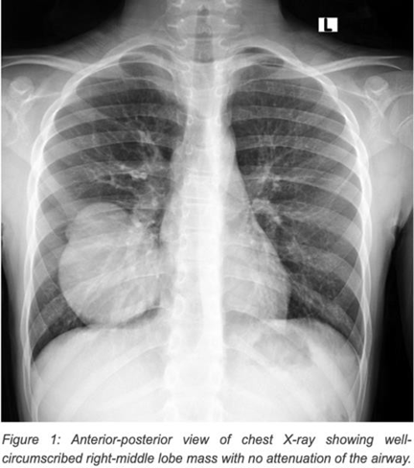
Figure 1. Anterior-posterior view of chest X-ray showing well-circumscribed right-middle lobe mass with no attenuation of the airway.
Biography
Francesca Maraschin is a South African medical doctor who spent 4 years working in public hospitals in Johannesburg before deciding to pursue masters at the University of Oxford where she studied International Health and Tropical Medicine. Her interests are in global child health and improving the wellbeing of children in low and middle-income countries. In her most recent position as a research assistant with Oxford’s Nuffield Department of Medicine, she has been working on two scoping reviews outlining specific topics on the needs of neonates in low-resource settings.

