Discovery of novel diarylpyrimidine derivatives as potent HIV-1 non-nucleoside reverse transcriptase inhibitors through computer-aided drug design
Xiangyi Jiang*, Xinyong Liu and Peng Zhan
Shandong University, China
Abstract
To overcome the drug resistance of HIV-1 Non-Nucleoside Reverse Transcriptase Inhibitors (NNRTIs), a series of novel diarylpyrimidine derivatives with improved resistance profiles were discovered through computer aided drug design [Figure 1]. The cocrystal structure of Etravirine (ETR) and HIV-1 Reverse Transcriptase (RT) showed that the aminobenzonitrile moiety of etravirine pointed to an extended channel, consisting of F227 and P236 that leads to the solvent-exposed region. To enhance backbone-binding interactions with F227 and P236, we designed a series of novel diarylpyrimidine derivatives bearing piperazine sulfonyl. After virtual screening using the software Surflex-Dock SYBYL-X 2.0, series of diarylpyrimidine derivatives with high virtual score were synthesized directly. The newly synthesized compounds were evaluated for their anti-HIV activities against via the MTT method in MT-4 cells. Among them, compound 18b1 displayed excellent anti-HIV-1 activities (EC₅₀=1.4-9.9 nM) against the wild-type and five mutations, which were obviously superior to that of approved drug etravirine. HIV-1 RT inhibitory assays indicated 18b1 possessed remarkably improved activities (IC₅₀=0.093 μM) compared with ETR (IC₅₀=1.35 μM). In order to calculate the potential binding mode between compound 18b1 and HIV-1 RT, Molecular Dynamics (MD) simulation studies were conducted through OPENEYE scientific software. The analysis results showed that the piperazine sulfonyl of 18b1 can generate additional interactions with the main chains of F227 and V106 in binding pocket, which explained the reason why 18b1 displayed better anti-HIV-1 activities than ETR. Overall, compound 18b1 is a promising lead compound and deserves further study.
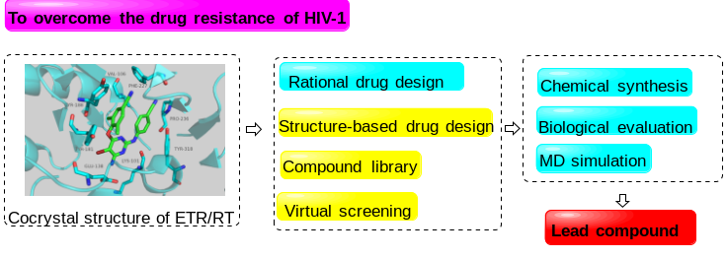
Figure 1. Discovery of novel potent HIV-1 NNRTIs through computer-aided drug design.
Biography
Xiangyi Jiang received his BS and MS degrees from the School of Pharmaceutical Sciences, Shandong University, in 2018 and 2021. He is currently pursuing a doctor degree in the Department of Medicinal Chemistry, School of Pharmaceutical Sciences Shandong University, working under the supervision of Professor Xinyong Liu and Professor Peng Zhan. His research interest focuses on the discovery of novel antiviral lead compounds, such as HIV-1, HBV and SARS-CoV-2.

