Food analysis
Oumou Diakite
Stanford University School of Medicine, USA
Abstract
Statement of the problem: The dominant foods were wheat flour and vegetable oil (75%) in occurrence of 25 for the first and 24 of the second, then apple jumps was the less dominant (2%, 2 in occurrence). For others like plantain bananas, poultry feed, raw vegetables, sesame oil between 70% and 45%. Infant flour, goulash hongrois, chocolate, livestock feed, miankala chips, braised fish around 25%-50% were the middle content of our research [Figure 1].
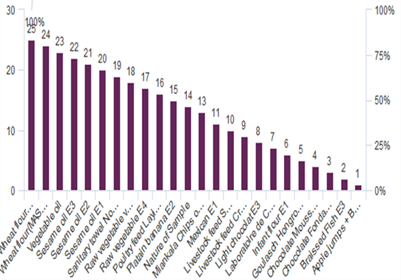
Figure 1. The nature of samples NHL (National Health Laboratory).
Methodology & theoretical orientation: The files of the National Health Laboratory were used for our data collection. The entered data were collected by questionnaire in Excel and analyses by Sphinx [Figure 2].
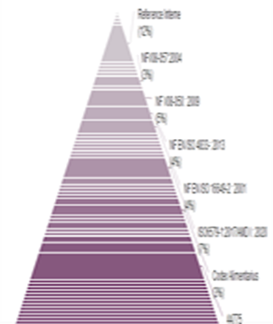
Figure 2. The methods for the food analysis used in NHL.
Findings: Food pathogens are mainly bacteria, viruses, or even parasites that are present in the food and are the cause of major diseases such as food poisoning.
The salmonella was the major germs 30% with 8% for aerobic germs, ash, Escherichia coli, germs mesophilic, and Staphylococcus aureus.
The humidity was 6% with 4% dry then 2% of iron, acid, fat, calcium, iode, nitrogenous, phosphors, protein, soap, vitamin.
Conclusion: Many of the technique of food analyses are not available in Mali. That limits our research to provide more information about food analyses.
Biography
Oumou Diakite has completed her postdoctoral studies at the age of 37 years from Alison University and her doctoral studies from Gamal Abdel Nasser University School of Medicine. She wrote ‘the micronutrients and pregnancy and the book of standard dietetic of hospital’. She participated to UNITAR, Global Symposium on Soils for Nutrition webinars and speaker in 3rd World summit on Food and Nutrition (conference series LLC Ltd).

