Rate settings and ventilation during Nasal Intermittent Positive Pressure Ventilation (NIPPV) in premature infants: A prospective, controlled, crossover study
Hochwald Ori*, Borenstein-Levin Liron, Dinur Gil and Kugelman Amir
Rambam Medical Center, Israel
Abstract
Objective: To examine the change in CO₂, when applying NIPPV with either a low or a high rate in stable premature infants.
Study design: Single center, prospective, controlled crossover study. Preterm infants on NIPPV were monitored by transcutaneous CO₂ monitor (tcCO₂) during three consecutive time periods of one hour each on a high (30 bpm) and low (10 bpm) set rate of NIPPV. NIPPV rate was randomly set as high/low, changed to low/high and vice versa. tcCO₂ was documented 1 hour after each change. We considered a clinically significant change in CO₂ level as 5 mmHg.
Results: Fifty premature infants (mean ± SD: 28.3 ± 2.4 weeks’ gestation) were enrolled. Each infant had two rate changes; therefore, a hundred rate changes were studied. The mean change in tcCO₂, i.e., ΔtcCO₂ (95% confidence-interval), was -1.1 (-2.3 to 0.1) mmHg for increasing rate from low to high and 0.46 (-0.49 to 1.41) mmHg for decreasing rate from high to low (Figure 1). There was no significant change in spontaneous respiratory rate, FiO₂, desaturations, apnea and bradycardia events, but mean airway pressure and oxygen spO₂ increased (p<0.05).
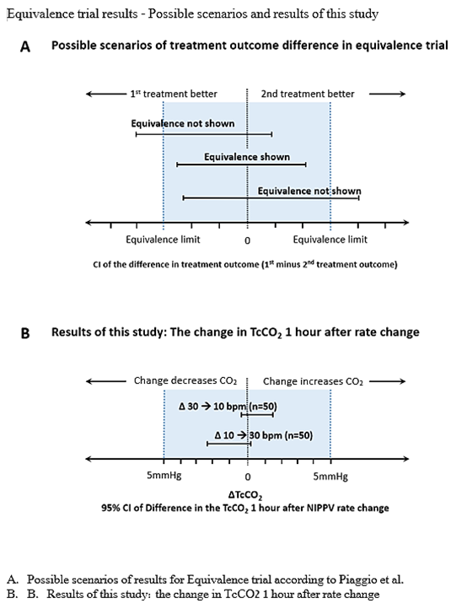
Figure 1. Equivalence trail results-possible scenarios and results of this study.
Conclusion: Multiplying or dividing the rate settings by three did not significantly change the tcCO₂ readings an hour after the change. These findings could affect the management of ventilation settings of NIPPV in premature infants.
Biography
Ori Hochwald is head of NICU in Rambam medical center, Haifa, Israel.

