Vaccine antigens against SARS-CoV-2 based on viral proteins fused to the extracellular domain of human CD154 (hCD40L)
Thailin Lao*, Ileanet Avalos, Yamila Carpio and Mario Pablo Estrada
The Center for Genetic Engineering and Biotechnology (CIGB), Cuba
Abstract
Statement of the problem: Since the emerge of SARS-CoV-2 more than 500 million people have been infected with this virus and more than 6 million people have died. To stop the COVID-19 pandemic, many vaccines have been developed mainly based on the S protein of the virus or its RBD domain to generate neutralizing antibodies. However, the N protein of SARS-CoV-2 is also a potential target for the development of vaccine candidates because is the most abundant, highly conserved and immunogenic protein. In this work, two chimeric proteins were constructed through the fusion of the RBD and N proteins of SARS-CoV-2 to the extracellular domain of human CD154 as a molecular adjuvant (RBD-CD and N-CD proteins) [Figure 1].
Methodology & theoretical orientation: HEK-293 cells were transduced with lentiviruses carrying the RBD-CD or N-CD gene and polyclonal cell populations and clones were obtained. RBD-CD and N-CD proteins were purified from culture supernatant and further characterized by various techniques, including SDS-PAGE, Western Blot and mass spectrometry. Immunogenicity studies were performed in mice and monkeys for each protein.
Findings: These studies demonstrated that the RBD-CD and N-CD proteins were highly immunogenic after two doses, inducing high IgG titers in both models and a long-lasting response in monkeys. In addition, the overall health monitoring of the monkeys showed that the animals remained healthy throughout the experiment. Likewise, sera from monkeys immunized with RBD-CD showed neutralizing activity against SARS-CoV-2 by an experiment with Vero E6 cells.
Conclusion: These observations support the safe use of both proteins as vaccine antigens. Both proteins could be used in combination with current RBD-based vaccines to enhance and prolong the cellular and humoral response elicited by these vaccines. Further experimentation will be necessary to confirm the efficacy of this combinatorial approach and its usefulness as prophylactic and/or booster vaccines.
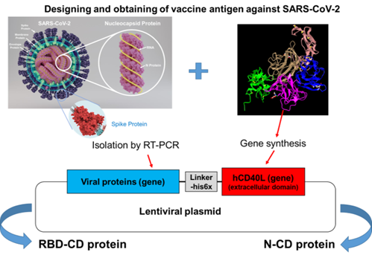
Figure 1. Designing and obtaining of vaccine antigen against SARS-COV-2.
Biography
Thailin Lao is a young PhD student. She has a BSc in Biochemistry and Molecular Biology and an MSc in Biochemistry from University of Havana, Cuba. She has experience in the expression of recombinant proteins in mammalian cell lines for the production of monoclonal antibodies and subunit vaccines. She worked in the Center of Molecular Immunology in Havana and now she is a researcher in the Center of Genetic Engineering and Biotechnology, where she works in the development of veterinary vaccines. She also has expertise in molecular biology, protein purification and characterization, cell culture and animal experimentation. She contributes as professor in the Faculty of Biology (University of Havana) teaching protein expression in mammalian cell lines. Her scientific career is endorsed by 4 scientific publications in international journals.

