Medicine 5.0: Bringing medicine together with technology
Emina Arcan
Arcan, United States
Abstract
Medicine 5.0 represents a systems-based approach to healthcare that aims to improve patient outcomes, reduce costs and enhance the patient experience through integrating technology and data. This approach includes several key aspects such as personalized medicine, telemedicine, artificial intelligence and machine learning, interoperability and patient engagement.
Personalized medicine involves the use of an individual's genomic, epigenomic, transcriptomic, proteomic and metabolomic information to optimize health and disease prevention, diagnosis and treatment. Telemedicine, on the other hand, is the delivery of healthcare services remotely using telecommunication technology, enabling patients to receive care in their homes.
Artificial Intelligence (AI) and machine learning are key components of Medicine 5.0. AI can be used to analyze large amounts of data, including medical records, lab results and patient outcomes, to identify patterns and trends that can help to improve patient care. Additionally, AI can be used to develop personalized treatment plans and to predict patient outcomes. This is particularly important in the context of vaccines, where AI can aid in the distribution of vaccines by identifying patterns of who would benefit from a certain vaccine, tracking vaccine stocks and even predicting future outbreaks.
Interoperability refers to the ability of different systems and devices to work together seamlessly, which is crucial for the integration of technology in healthcare. Patient engagement involves the active involvement of patients in their own healthcare, including decision-making and self- management of their health [Figure 1].
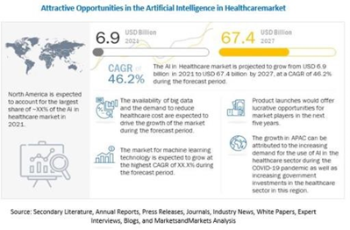
Figure 1. Attractive opportunities in the artificial intelligence in health market.
It is important to note that AI is not without its limitations. The technology is still in its early stages and it is crucial to ensure that any AI-based systems are properly validated and that patient privacy is protected. Additionally, as with any new technology, there is a potential for unintended consequences and biases.
In conclusion, Medicine 5.0 represents a new approach to healthcare that aims to improve patient outcomes, reduce costs and enhance patient experience through integrating technology and data. The use of AI and machine learning, personalized medicine, telemedicine, interoperability and patient engagement are key aspects of this approach.
With its ability to analyze large amounts of data and identify patterns, AI has the potential to play a major role in the implementation of Medicine 5.0, particularly in the context of vaccine distribution. However, it is important to consider AI's limitations and potential unintended consequences and ensure that patient privacy is protected.
Biography
Emina Arcan is a highly experienced healthcare executive and licensed registered nurse. She currently serves as the Chief Technology Officer, where she has been recognized as one of top America's Best Ambulatory Surgery Centers. With over 10 years of experience in nursing and leadership, she is a five time recipient of the Daisy Award, an award given to nurses who provide exceptional patient care. She is known for her strategic leadership skills and her ability to develop positive relationships with patients, their loved ones, physicians, vendors and executives. She is dependable, highly organized and pays close attention to detail. She is driven by her passion for providing the highest quality of patient care and follows the philosophy of the "Mother Standard of Care", treating every patient as if they were her own mother.

