Method applied to molecular structures, spectroscopic parameters and electronic properties of some new 4-nitro- and 4-allylamino-N-phenyl-1,8-naphthalimides in different solvents
Bénédicte TouogamTouolak
Anhui University of Science and Technology, China
Abstract
In the present work, the analyses of molecular structures and spectroscopic parameters using quantum chemical computations at the B3LYP/6-311G (d,p) level of theory for the 4-nitro-N-phenyl-1,8-naphthalimide and 4-allylamino-N-phenyl-1,8-naphthalimide molecules as 1,8-naphthalimide derivatives have been successfully verified [Figure 1]. In terms of bond lengths and bond angles, the closest values compared with the crystallographic data of the 1,8-naphthalimide ring seem to be obtained by the B3LYP method of theory. However, for the spectroscopic parameters values, the B3LYP method mostly gives better results [Figure 2]. Furthermore, the calculated maximum electronic absorption wavelength values in MethylCycloHexane, Methanol, AceticAcid, Acetone, Acetonitrile, Chloroform, Dichloromethane, DiMethylSulfoxide, Ethanol, TetraHydroFuran, Toluene and Water solvents, also with ¹H and ¹³C NMR chemical shift values in gas phase, chloroform and ethanol solvents for the 4-nitro-N-phenyl-1,8-naphthalimide and 4-allylamino-N-phenyl-1,8-naphthalimide molecules can be built into a database for other 1,8-naphthalimide derivatives that will be synthesized or studied in the light of pharmacology, bio imaging and biologic activities.
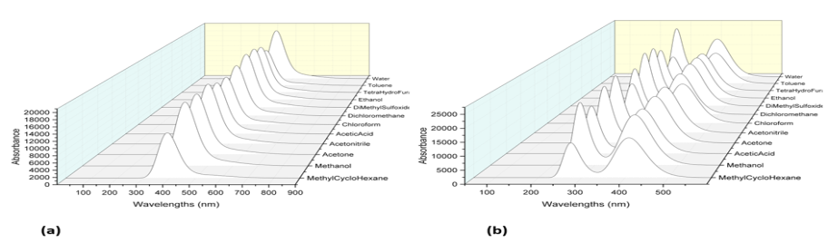
Figure 1. The simulated UV-vis spectra in different solvents of (a) 4-nitro-N-phenyl-1,8-naphthalimide and (b) 4-allylamino-N-phenyl-1,8-naphthalimide.
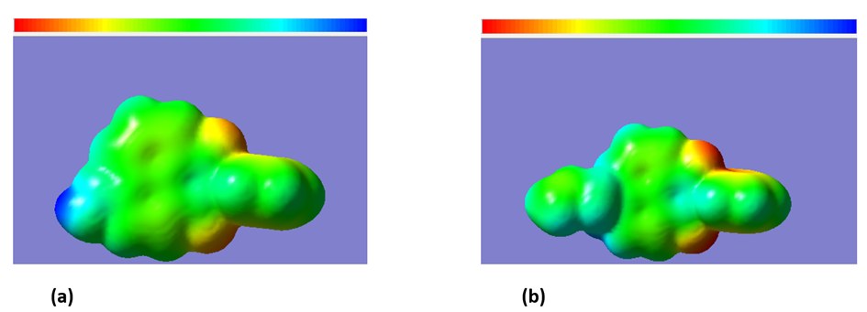
Figure 2. Molecular electrostatic potential surface of (a) 4-nitro-N-phenyl-1,8-naphthalimide and (b) 4-allylamino-N-phenyl-1,8-naphthalimide obtained at the B3LYP level.
Keywords: Computational chemistry, Photophysics, Fluorescent copolymers, Polymerizable naphthalimides.
Biography
Bénédicte TouogamTouolak, PhD and affiliated from Anhui University of Science and Technology, Huainan, Anhui, China.

