Brain injury caused by bacterial meningitis: The need for a community-based awareness and pathogen surveillance in Nigeria
Ismail Rabiu
Bayero University Kano, Nigeria
Abstract
In today’s world, epidemics caused by bacterial meningitis are considered a major public health threat affecting tropical countries, predominantly in sub-Saharan Africa. Cerebrospinal meningitis caused by bacterial species is considered a common disease in Nigeria, especially in the Northern part of the country. Globally, researchers have indicated the high burden of the disease mostly in Africa. Of all the countries located in the meningitis belt, Nigeria has the highest recorded cases of meningitis with 21% of the total cases. Meningitis is a disease condition leading to the inflammation of the brain and spinal cord tissues. In the Hausa language, which is the most populous language in Nigeria and the predominant language spoken in Northern Nigeria, meningitis is referred to as “Ciwon sankarau”. Meningitis may be classified into bacterial and viral Meningitis. Viral meningitis is commonly encountered but has fewer complications. Bacterial meningitis is rare but can be so very deadly. It involves infection with some bacteria such as Neisseria meningitides, Streptococcus pneumoniae, and Haemophilus influenzae. As the infections progresses, they attack the brain cells and tissues leading to stroke, deafness, hearing loss and eventually brain damage. In Africa, around 1.2 million cases of meningitis caused by bacterial pathogens are set to occur annually with roughly 135,000 cases considered lethal. Considering the high cases of bacterial meningitis in Nigeria, coupled with the fact that everyone can get infected, irrespective of age, gender, or ethnicity along with its easy spread nature, there is the need for Community-based awareness and Pathogen Surveillance in Nigeria as this has proven effective in the control of similar infections [Figure 1].
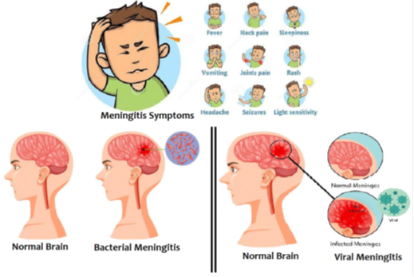
Figure 1. Symptoms of Meningitis, Bacterial and Viral meningitis.
Biography
Ismail Rabiu, is from Nigeria, having a BSc in Microbiology and MSc degree in Medical Microbiology. His passion for excellence, and wide reading habit made him break the long-standing record where he finished at the top of his class with Distinction during his graduate studies at Bayero University Kano. His motivation to learn novel techniques made him undergo different training on Infectious disease and Antimicrobial resistance with the Bloomberg School of public health and the United State Agency for International Development under the Global e-health learning. All these have provided him with skills in infectious disease Epidemiology and sustainable control strategies. His research interest cut across areas of Medical Microbiology, Epidemiology, and Public Health Microbiology. At present, He is a faculty, in the Department of Microbiology, Skyline University Nigeria. He holds the credit of being among the youngest faculties that implemented flip teaching and peer-based learning as novel teaching methodologies.

