Using a fibrinolysis delivery catheter in pulmonary embolism treatment for measurement of pulmonary artery hemodynamic
Abdelrahman Elhakim
Schoen Hospital, Germany
Abstract
Background: Ultrasound-facilitated and catheter-directed low-dose fibrinolysis (EKOS) has shown favorable hemodynamic and safety outcomes in intermediate- to high-risk Pulmonary Embolism (PE) cases.
Objectives: This prospective single-arm monocentric study assessed the effects of using a delivery catheter for fibrinolysis as a novel approach for acute intermediate to high-risk patients on pulmonary artery hemodynamics PE.
Methods: Forty-five patients (41 intermediate high and 4 high risk) with Computer Tomography (CT)-confirmed PE underwent EKOS therapy [Figure 1]. By protocol, a total of 6 mg of tissue-Plasminogen Activator (t-PA) was administered over 6 h in the pulmonary artery (unilateral 6 mg or bilateral 12 mg). Unfractionated heparin was provided periprocedurally. The primary safety outcome was death, as well as major and minor bleeding within 48 of procedure initiation and at 90 days. The primary effectiveness outcomes were:
- To assess the difference in pulmonary artery pressure from baseline to 6 h post-treatment as a primary precise surrogate marker
- To determine the echocardiographic RV/LV ratio from baseline to 48 h and at 90 days post-delivery.
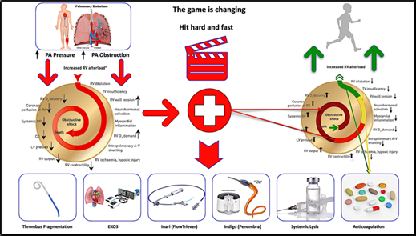
Figure 1. Central illustration demonstrating pulmonary embolism process. Shown is the mechanism of hemodynamic collapse and death in acute pulmonary embolism cases and how each risk group is treated (Braun=high risk; red=intermediate–high risk; yellow=intermediate–low risk; green=low risk). PA=Pulmonary artery; A-V=arterio-venous; BP=blood pressure; CO=cardiac output; LV=left ventricular; O₂=oxygen; RV=right ventricular; TV=tricuspid valve; Braun=high risk; red=intermediate–high risk; yellow=intermediate–low risk; green=low risk of PE.
Results: Pulmonary artery pressure decreased by 15/6/10 mmHg (p<0.001). The mean RV/LV ratio decreased from 1.2 ± 0.85 at baseline to 0.85 ± 0.12 at 48 and to 0.76 ± 0.13 at 90 days (p<0.001). Five patients (11%) died within 90 days of therapy.
Conclusion: Pulmonary artery hemodynamics were assessed using a delivery catheter for fibrinolysis, which is reproducible for identifying PE at risk of adverse outcomes. The results matched with Ultima trial, thereby confirming the validity of this potential diagnostic tool to assess therapy effectiveness and thereby reduce additional procedure-related complications, hospital residency and economics. These results stress the importance of having an interdisciplinary team involved in the management of PE and this protocol shortens ICU admission to 6 hours.
Biography
Abdelrahman Elhakim is an interventional cardiologist who specializes in invasive cardiology, intensive care and emergency medicine in Germany. He completed his cardiovascular medicine residency and interventional cardiology fellowships in many hospitals in Germany. He holds Master of Health and business administration at Nürenberg University in Germany and a Master in Cardiovascular Medicine at Al-Azhar University in Egypt. He is currently leader of workshops and webinars on pulmonary embolism in German hospitals. He is a head of catheter laboratory at Schoen clinic Neustadt in Holstein in Germany.

