Association between depression, happiness and sleep duration: Data from the UAE healthy future pilot study
Mitha Al Balushi
New York University, UAE
Abstract
Background: The United Arab Emirates Healthy Future Study (UAEHFS) is one of the first large prospective cohort studies in the region which examines causes and risk factors for chronic diseases among the nationals of the United Arab Emirates (UAE). The aim of this study is to investigate the eight-item Patient Health Questionnaire (PHQ- 8) as a screening instrument for depression among the UAEHFS pilot participants.
Methods: The UAEHFS pilot data were analyzed to examine the relationship between the PHQ-8 and possible confounding factors, such as self-reported happiness and self-reported sleep duration (hours) after adjusting for age, Body Mass Index (BMI) and gender.
Results: Out of 517 participants who met the inclusion criteria, 487 (94.2%) participants filled out the questionnaire and were included in the statistical analysis using 100 multiple imputations. 231 (44.7%) were included in the primary statistical analysis after omitting the missing values. Participants’ median age was 32.0 years (Interquartile Range: 24.0,39.0) (Table 1). In total, 22 (9.5%) of the participant reported depression. Females have shown significantly higher odds of reporting depression than males with an odds ratio=3.2 (95% CI:1.17,8.88) and there were approximately 5-fold higher odds of reporting depression for unhappy than for happy individuals. For one interquartile-range increase in age and BMI, the odds ratio of reporting depression was 0.34 (95% CI: 0.1,1.0) and 1.8 (95% CI:0.97,3.32) respectively (Table 2).
Conclusion: Females are more likely to report depression compared to males. Increasing age may decrease the risk of reporting depression. Unhappy individuals have approximately 5-fold higher odds of reporting depression compared to happy individuals. A higher BMI was associated with a higher risk of reporting depression. In a sensitivity analysis, individuals who reported less than 6 hours of sleep per 24 hours were more likely to report depression than those who reported 7 hours of sleep.
Table 1. Number (percentages) of the analysed variables and median (IQR) for age and BMI.
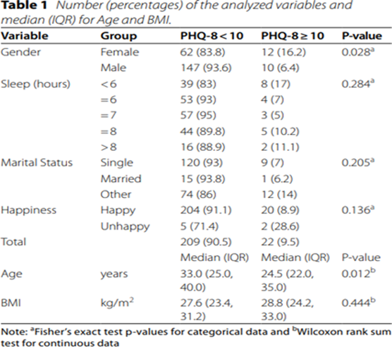
Table 2. The results of the primary analysis of the fitted multivariate logistic regression model.
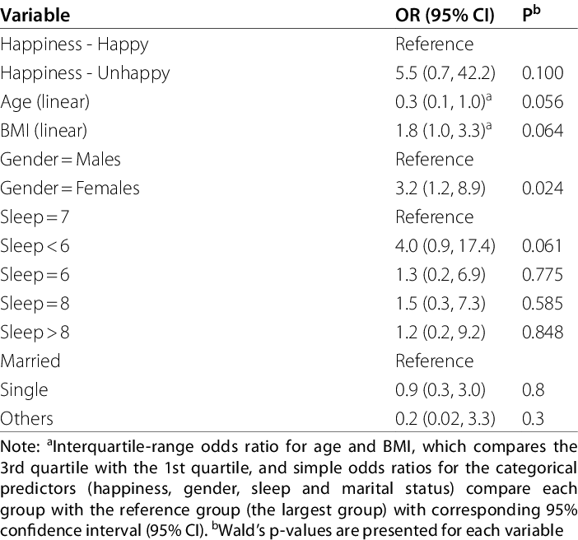
Biography
Mitha Al Balushi is a research associate in the Public Health Research Center-New York University Abu Dhabi. She is a PhD candidate in public health-the institute of public Health of the UAE University. She had post graduate Diploma in Diabetes from Sweden and her degree in nursing sciences from Griffith Australian University. Her experience is over 15 years in public health and clinical nursing care and research. Some of her research was published in peer reviewed high IF international journals. She presented her research in nation and international conferences. She is an active member of the Emirates Public Health Association.

