Label and radiation-free CEST MRI detection of amyloid: Repurposing of the PiB PET probe
Caiyu Zhuang*, Beibei Chen and Renhua Wu
Shantou University Medical College, China
Abstract
Statement of the problem: The compound PiB has been radio-labeled for PET imaging of amyloid, which is critical in the detection of amyloid and enables early diagnosis of dementia. This study aims to repurpose PiB for label and radiation-free CEST MRI imaging, which would be promising in clinical transformation.
Methodology & theoretical orientation: PiB solutions at different concentrations were prepared for the Z-spectra measurements. After optimizing parameters by preliminary experiments, APP/PS1 transgenic mice (n=6) and age-matched C57 mice (n=6) were used for in vivo CEST MRI imaging of amyloid on a 7.0 T MRI scanner. The brains were scanned dynamically after intraperitoneal injection of PiB. Finally, the pathological assessment was conducted in the same brain slices to evaluate the correlation between the MRI signal abnormality and the deposition of beta-amyloid detected by immunohistochemical staining.
Findings: The Z spectra revealed a clear CEST effect peaked at approximately 6 ppm, which could be distinguished from the inherent amide proton transfer and magnetization transfer when applied to in vivo CEST MRI imaging. APP/PS1 mice injected with PiB showed a significantly higher in vivo CEST effect when compared with controls and before injections (p<0.05). The distribution of Aβ deposits detected by CEST imaging was consistent with the immunohistochemical staining results [Figure 1].
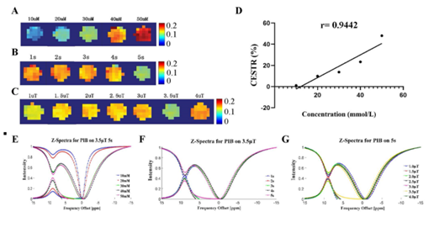
Figure 1. In vitro CEST effect assessment of PiB. (A) The CEST images of PiB at different concentrations. The CEST images of PiB with different saturation times (B) and saturation powers (C)-(D) The relationship between CEST effect and concentration of PiB. (E-G) The Z-spectra of PiB with different concentrations, saturation times and saturation powers respectively.
Conclusion: The present study is the first to repurpose a PET probe to noninvasively evaluate Aβ deposits in APP/PS1 mice. Repurposing of the PiB PET Probe for CEST MRI imaging enables label and radiation-free detection of amyloid and has potential in clinical transformation, especially in the early detection of dementia.
Biography
Caiyu Zhuang is a PhD candidate for neuroimaging. She is interested in chemical exchange saturation transfer (CEST) MRI, a molecular imaging technique sensitive in detecting in vivo metabolites or probes. She has explored the feasibility of using this technique to detect amyloid deposition in Alzheimer’s disease and also evaluated the efficacy of nanomedicine in treating glioma.

