Prevalence and socio-demographic correlates of mental health problems among Iranian health sciences students
Batool Tayefi Nasrabadi
Iran University of Medical Sciences, Iran
Abstract
Statement of the problem: University students are a high-risk population for certain mental health problems as well as experiencing a critical transitory period in which developmental challenge of transition to adulthood occurs. Our two purposes in this study were (a) to describe the prevalence of selected mental health problems among a representative sample of Iranian health sciences students and (b) to examine the socio-demographic correlates of these psychological problems in Iranian health sciences students.
Methodology & theoretical orientation: A total of 560 medical and other health sciences students (250 males and 310 females) were recruited from Iran University of Medical Sciences. Data were obtained by self-administered questionnaire, including questions on socio-demographic characteristics. The Beck Depression Inventory, Beck Anxiety Inventory, General Health Questionnaire and WHO well-being index were used.
Findings: Ten percent of students had BDI scores consistent with clinically significant depression (6.6% mild, 1.8% moderate, 1.6% severe) and 28.7% had BAI scores consistent with clinically significant anxiety (20.7% mild, 7.1% moderate, 0.9% severe). Kurdish students had an Odds Ratio (OR) of 2.71 for mild to severe depression symptoms when compared to Persian students. The prevalence of distressed health sciences students and poor psychological well-being was 13.4% and 14.1%, respectively. Maternal education gave an OR of 0.57 for anxiety symptoms, after adjustment for all other factors. The possibility of general psychiatric morbidity was significantly lower in students who studied medicine (OR, 0.40). Being born in the capital city was associated with better psychological well-being (OR, 0.48) [Table 1].
Table 1. Adjusted odd ratios of the association between psychological problems and socio-demographic factors.
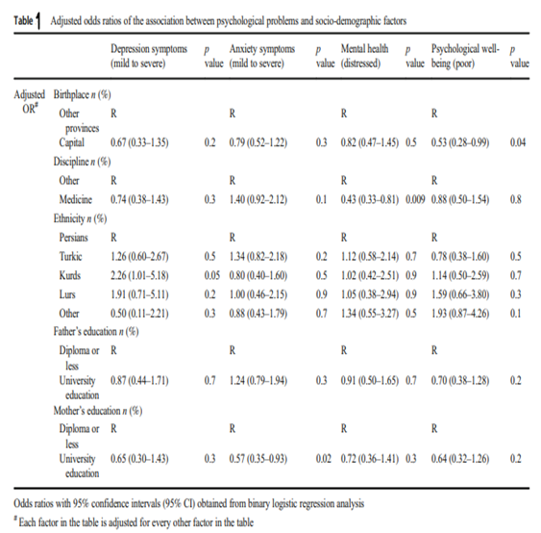
Conclusion: Ethnicity, birthplace, discipline and maternal educational level were major determinants of mental health status among health sciences students. Further research should be undertaken to determine the prevalence of psychological disorders using more reliable diagnostic interview.
Biography
Batool Tayefi Nasrabadi did Graduation and MD and working as a general practitioner for almost 10 years did not stop her from pursuing her interest in public health and community medicine in 2010 when she started her residency and specialty course at the School of Medicine, Shahid Beheshti University of Medical Sciences, where her research was focused on Social health. Since the completion of her specialty course, she started working in academia with a focus on research areas of social determinant of health. Since 2018, she had worked as an Assistant Professor in the Department of Community and Family Medicine at Iran University of medical Sciences. Moreover, she is a senior researcher in Preventive Medicine and Public Health Research Centre. In her recent research, she focused on mental health and well-being in university students and also physical activity level in employees as the social determinants of health.

