The association between gut microbiota, metabolome and kidney function decline
Hsiu-Ling Chen, Chia-I Lin
Department of Food Safety / Hygiene and Risk Management, NCKU, Taiwan

Abstract
Chronic kidney disease (CKD) is defined by having abnormalities of kidney function or structure present for more than 3 months. CKD is an expensive financial burden for the healthcare system due to the majority of patients with early CKD stage are unrecognized, and that may probably delay diagnosis and progression to End Stage Renal Disease (ESRD). In general, kidney function declines with age in almost everyone. However, few CKD patients’ kidney function sudden drop unexplainedly. The connection between gut and kidney, which is called the gut-kidney axis, had been proposed. The gastrointestinal tract has a regulatory effect on kidney function. The results showed that the interaction between CKD and microbiota affects the host pathophysiological metabolism. Gut dysbiosis in CKD is accompanied by systemic inflammation and comorbid diseases, resulting in dysregulation of metabolic pathways.
Dysregulation of this axis will lead to a vicious circle, contributing to CKD progression. Nevertheless, the changes in microorganism in CKD with kidney function decline and underlying mechanism are limited. Therefore, this study aims to explore the links between microbes each other or between microbes and metabolites in CKD. First, the subjects which recruit from National Cheng Kung University Hospital will be divided into case and control group based on decline in kidney function. Plasma and urine metabolomics approach using UPLC-QTOF-MS is carried out. Multivariate data analysis is used to identify differential metabolites. Next, fecal samples from patients who with differential metabolites are sequenced to determine the composition of the gut microbiome.
Statistically significant species for each group are evaluated by the LEfSe (linear discriminant analysis of effect size) analysis, and further explore the connection with microbes and metabolites by
Spearman correlation analysis. Lastly, identify the potential biomarkers for predicting renal function decline in CKD. Keywords: chronic kidney disease, kidney function decline, gut microbiota, metabolomics, metabolic pathway

Image
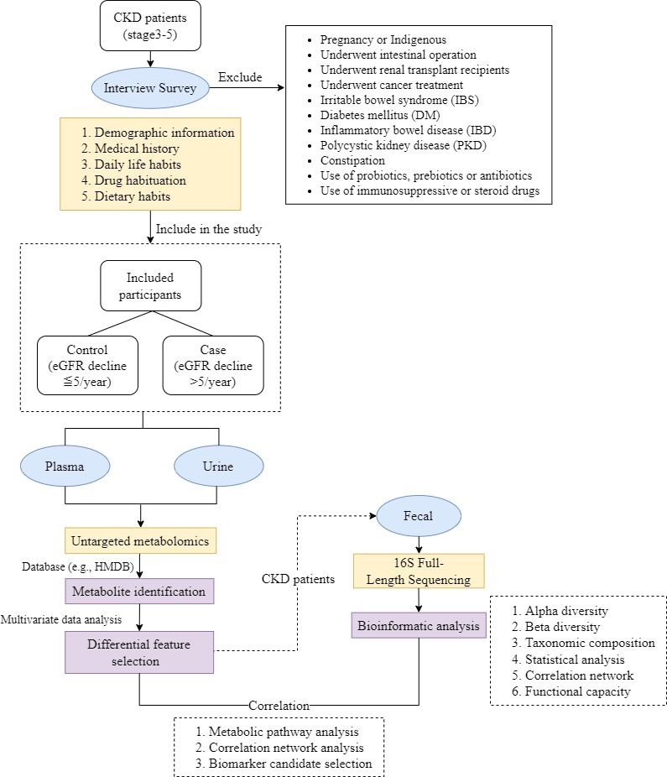



Biography
Chia-I Lin is a graduate student from Department of Food Safety/Hygiene and Risk Management, National Cheng Kung University. She has passion in research and is willing to work hard to overcome difficulties. In the level of her food science degree, Chia-I spent her summers working in food processing industry. Those experiences convinced her to continue to study in food safety and risk management. Her current research is focus on metabolomics and gut microbiota for providing new discoveries in precision medicine which is a treatment option to delay progression of kidney disease.
Email: sc6101076@gs.ncku.edu.tw

Presenting author details

Full name: Chia-I Lin
Contact number: +886988683170
Session name: Department of Food Safety / Hygiene and Risk Management, NCKU, Taiwan Category: Poster presentation

