Investigate the role of Thioredoxin domain-containing protein 5 (TXNDC5) in peritoneal dialysis-induced peritoneal fibrosis
Chun-Jung Chien*, Kai-Chien Yang and Pei-Shiue Jason Tsai
National Taiwan University, Taiwan
Abstract
Statement of the problem: Peritoneal Dialysis (PD) is one of the kidney replacement therapies that maintain the lives of patients with kidney failure. Long-term PD will lead to Peritoneal Fibrosis (PF), which would cause functional and morphologic changes in the peritoneum and eventually result in ultrafiltration failure. Despite efforts being made, there is still no effective treatment that has been developed to alleviate PF. Recently, an endoplasmic reticulum protein, Thioredoxin Domain-Containing protein 5 (TXNDC5), was identified as a novel mediator in the process of organ fibrosis in multiple organs. The purpose of this study is to explore a potential target to treat ultrafiltration failure by investigating the role of TXNDC5 in PF.
Methodology & theoretical orientation: A 5-week Methylglyoxal (MGO)-induced peritoneal fibrosis mouse model was established and the peritoneal tissue was harvested to validate the expression of fibrosis-related proteins and protein expression of TXNDC5 via western blot and immunofluorescence staining.
Findings: Histological and Masson’s trichrome staining showed MGO-induced significant peritoneum thickening when compared with PD fluid control group, indicating that the PF was successfully established (Figure 1). Immunofluorescent staining confirmed that an increased TXNDC5 signal was present at the thickened parietal peritoneum. In addition, western blot results showed that both TXNDC5 and fibrogenesis-related signaling were upregulated in MGO-induced peritoneum (Figure 2). Using Col-GFP transgenic mice (Col1a1-GFPTg), we showed mesothelial cells became Col-GFP positive on the peritoneal surface, indicated that mesothelial cells expressed collagen I secreting ability after MGO-induction and likely play a role in the progression of MGO-induced peritoneal fibrosis (Figure 3).
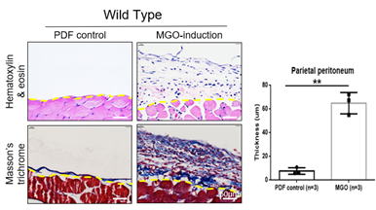
Figure 1. MGO-induced peritoneum thickening with collagen accumulation.
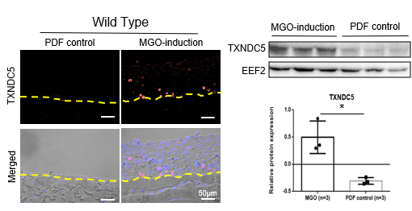
Figure 2. TXNDC5 protein expression was upregulated in MGO-induced peritoneum.
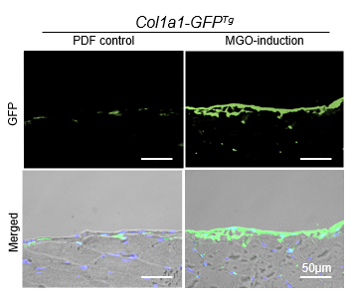
Figure 3. MGO-induced mesothelial cells expressed Col1a1 signal.
Conclusion: TXNDC5 protein expression is increased after MGO induction and is positively correlated with fibrogenesis-related signaling. Therefore, targeting TXNDC5 could be a potential therapeutic approach against the development of PD-induced PF, which may prolong the service life of PD patients.
Biography
Chun-Jung Chien majors in veterinary medicine at NPUST, after obtaining her DVM license, she continues her study for a master degree in the conservation reproductive biology and regenerative medicine lab at the graduate institute of Veterinary Medicine at National Taiwan University. Her research focuses on investigating the mechanism of peritoneal dialysis-induced fibrosis and exploring novel therapeutic approaches for peritoneal fibrosis.

