Effects of exposure to organophosphate pesticides on renal function and metabolomic signatures of patients with chronic kidney disease
Yu Chi, Hung, M.S.
Department of Food Safety / Hygiene and Risk Management, National Cheng Kung University Hospital (NCKUH), ROC

Abstract

In Taiwan, organophosphates pesticides (OPPs) account for a quarter of the total use of the registered pesticides in Taiwan. Six dialkyl phosphates (DAP) metabolites are excreted in the urine after people expose to OP pesticides. OP may inhibit the activity of acetylcholinesterase in the body, and then exhibits toxic effects on the nervous system, liver, and kidneys. The possible effects of OP residues in crops on sensitive groups have attracted much attention in recent years. Blood circulation, electrolyte balance and excretion in kidneys are partly controlled by cholinergic, therefore, exposure to OP pesticides may impair renal function.
High dose exposures in short period may cause acute kidney injury, and long-term exposure to OP pesticides may affect the progression of Chronic Kidney Disease (CKD). Some studies have observed an association between urine biomarkers of pesticide and CKD, however, no metabolomic study focus on the effects of exposure to OP pesticides on CKD patients. Followed by untargeted metabolomic analysis in plasma and urine using an UPLC Q-TOF-MS. Then to identify the differential metabolites related to disease and phenotype to figure out their related biological metabolic pathways.
This study aims to investigate the effects of exposure to OPs on metabolic pathways and disease progression in CKD patients in three to five stage. Therefore, a cohort study for CKD will be conducted, and both urine and blood were collected from patients with CKD in three to five stage.
Finally, to explore the correlation of 8-OHdG concentrations, CKD progression, and also specific biological metabolic pathways after exposing to organophosphate pesticides in patients. In the future, it is hoped that finding potential biomarkers related to diet and living habits, it is expected to delay the progression of CKD patients into end-stage renal disease (ESRD).
Keywords: Chronic kidney disease, Organophosphate pesticides, Metabolomics, Oxidative stress, Renal function

Image
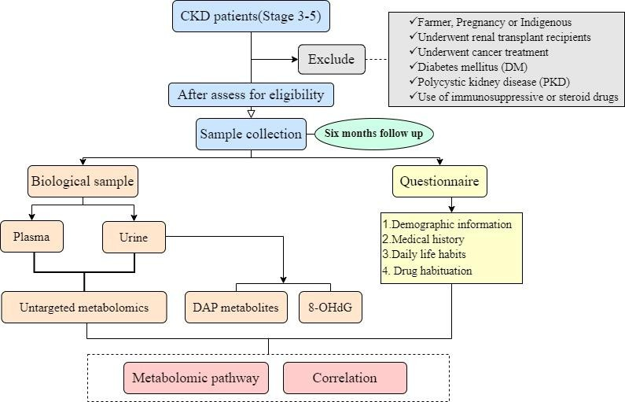
Recent Publications

Herianto, S., Shih, M.-K., Lin, C.-M., Hung, Y.-C., Hsieh, C.-W., Wu, J.-S., . . . Hou, C.-Y. (2022). The effects of glazing with plasma-activated water generated by a piezoelectric direct discharge plasma system on whiteleg shrimp (Litopenaeus vannamei). LWT, 154, 112547.
- Alissa, K., Hung, Y. C., Hou, C. Y., Lim, G. C. W., & Ciou,
J. Y. (2020). Developing New Health Material: The Utilization of Spray Drying Technology on Avocado (Persea Americana mill.) Seed Powder. Foods, 9(2).


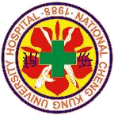
Biography
With a background in the department of Food Science before, I committed myself to solving problems in food safety, the factors that need to be considered and the level of evaluation often involve food chemistry, food microbes, and food processing, it is necessary to understand the hazards that will occur during the food manufacturing process to further control safety. After doing different research including food development and application of plasma in aquaculture. Also, I tried to figure out the relationship between diet and human health. Now studying in the metabolomic study mainly focus on the effects of exposure to OP pesticides on CKD patients in Taiwan. It aims to investigate the impact of exposure to OPs on metabolic pathways and disease progression in CKD patients in three to five stages. I hope that the research can contribute to our society and improve the well-being of these patients.
Email: 1. a0922218820@gmail.com /2. sc6104040@gs.ncku.edu.tw

Notes/Comments:
Presenting author details

Full name: Yu Chi, Hung
Contact number: +886 922 218 820 Session name/ number:
Category: Poster presentation 8F., No. 138, Shengli Rd., North Dist., Tainan City 704302 , Taiwan (R.O.C.)

