Water stable, red emitting, carbon nanoparticles stimulate 3D cell invasion via clathrin-mediated endocytic uptake
Udisha Singh*, Aditya Guduru Teja, Shanka Walia, Payal Vaswani, Sameer Dalvi and Dhiraj Bhatia
Indian Institute of Technology Gandhinagar, India
Abstract
Bright, fluorescent nanoparticles with excitation and emission towards the red end of the spectrum are highly desirable in the field of bioimaging. We present here a new class of organic Carbon-based Nano Particles (CNPs) with robust quantum yield and fluorescence towards the red region of the spectrum. Using organic substrates like Para-Phenylenediamine (PPDA) dispersed in diphenyl ether and reflux conditions, we achieved scalable amounts of CNPs of the average size of 27 nm. These CNPs were readily up taken by different mammalian cells and we show that they prefer clathrin-mediated endocytosis for their cellular entry route. Not only can these CNPs be specifically up taken in cells, but they also stimulate cellular processes like cell invasion from 3D spheroid models. We also performed in-vivo studies in zebrafish larvae at different concentration and time point. These new classes of CNPs, which have sizes similar to proteinaceous ligands, hold immense potential for their surface functionalization. They could be explored as promising bioimaging agents for biomedical imaging and intracellular drug delivery [Figure 1].
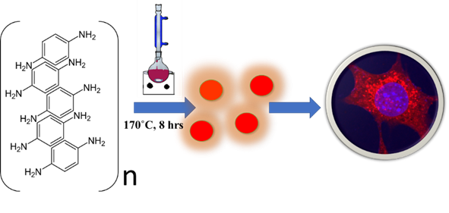
Figure 1. Schematic representation of CNPs synthesis using para-phenylenediamine dissolved in diphenyl ether, refluxed at 170ºC for 8 h leading to one-step formation of red emitting nanoparticles that could be up taken by cells for bioimaging applications.
Biography
Udisha Singh is a PhD scholar at Indian Institute of Technology, Gandhinagar, Gujarat. She is currently working in the supervision of Dr. Dhiraj Bhatia as her P.I. Her main research fields are synthesis of nanoparticles, especially carbon dots and their biomedical application. Her PhD research work is more focused on the optical properties of nanoparticles and their use in bioimaging applications as well as study their intake studies by the mammalian cells to get a better idea of applications of these nanoparticles in biological systems.

