Numerical analysis of MHD combined convective nanofluid flow in a lid driven enclosure equipped with corrugated boundary and internal heat source
Kakali Chowdhury^{1,2}, Md. Abdul Alim²
¹Presidency University, Gulshan-2, Dhaka, Bangladesh
²Bangladesh University of Engineering and Technology, Dhaka-1000, Bangladesh

Abstract
The problem of MHD combined convection is analyzed in a lid driven enclosure with corrugated wavy bottom wall filled with $Cu-H_{2}O$ nanofluid in presence of internal heat source. The top and right walls of the enclosure are maintained with a uniform cold temperature $T_{c}$ whereas the left wall and bottom wavy wall are kept adiabatic. The top wall is moving with a constant velocity upon its lid and a rectangular heat source is placed horizontally inside the enclosure. The physical problems are characterized by 2D governing partial differential equations along with proper boundary conditions and are discretized using Galerkin’s finite element formulation. The study is executed by analyzing different ranges of geometrical and physical parameters namely, the ratio of heat source and cavity height ($0.05≤a/H≤0.2)$, volume fraction of nanoparticles$(0≤φ≤0.09)$, Hartmann number $(0≤Ha≤90)$ and Richardson number $(0.1≤Ri≤10)$. The numerical results show that, in the combined convection region. In absence of magnetic field, heat transfer rate decreases approximately 3%, 9% and 24% with the increasing value of the ratio (heat source height and cavity height) from $0.05 to 0.07, 0.1 and 0.2$ respectively. In comparison with flat wall, heat transfer rate increases about 9% and 16% respectively with the increasing wave number of corrugated wall to 2 and 4. Heat transfer rate increases about 8% and 16% and 25% respectively with the increasing value of volume fraction 3%, 6% and 9% respectively in comparison with base fluid. Heat transfer rate starts to decline with the instigation of magnetic field. It decreases approximately 26% and 53% with the increasing value of $Ha$ from 0 to 30 and 60 respectively.

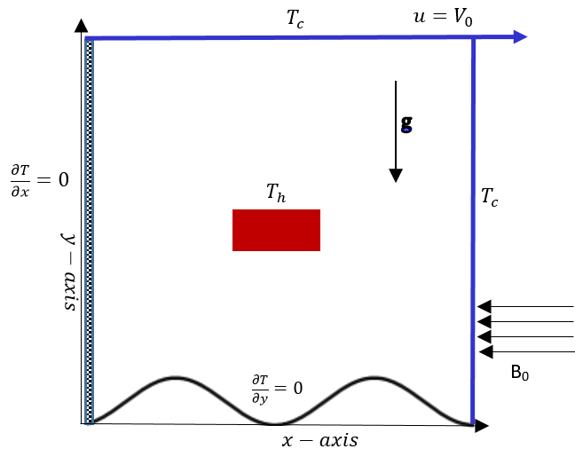
Figure 1: Schematic diagram with co-ordinate system
Recent Publications:
[1] K. Chowdhury, M.A. Alim, Mixed convection in a double lid-driven wavy shaped cavity filled with nanofluid subject to magnetic field and internal heat source, Journal of Applied Mathematics, Hindawi, vol. 2023 |Article ID 7117186|
https://doi.org/10.1155/2023/7117186
[2] K. Chowdhury, A. Alim, M. Hossen, Natural convection in a partially heated and cooled square enclosure containing a diamond shaped heated block, International Journal of Fluid Mechanics & Thermal Sciences, vol. 6(1), pp. 1-8, 2020.
doi: 10.11648/j.ijfmts.20200601.11
[3] K. Chowdhury, A. Alim, MHD mixed convection flow in a lid driven enclosure with a sinusoidal wavy wall and a heated circular body, International Journal of Fluid Mechanics & Thermal Sciences, vol. 5(4), pp. 102-110, 2019.
doi: 10.11648/j.ijfmts.20190504.13
[4] K. Chowdhury, Effect of the presence of a heated circular obstacle on natural convection inside a square enclosure, Presidency University Journal, Bangladesh, vol. 3(2), pp. 38-46, 2016
http://presidency.edu.bd/uploads/Article018.pdf
[5] K. Chowdhury, M.A. Alim, Analysis of MHD mixed convection flow within a square enclosure containing a triangular obstacle, American Journal of Applied Mathematics, vol. 3(6), pp. 288-296, 2015.
http://dx.doi.org/10.11648/j.ajam.20150306.18


Biography:
Kakali Chowdhury is working as a faculty member of Mathematics in the department of Electrical and Computer Engineering of Presidency University, Dhaka, Bangladesh. She obtained her B.Sc. and M.Sc. degree from Rajshahi University, Rajshahi, Bangladesh. She has obtained her M.Phil degree from Bangladesh University of Engineering & Technology (BUET), Dhaka and now she is continuing her Ph.D. degree in BUET, Dhaka also. Besides teaching, for a long time she is engaged in the research work in the area of Computational Fluid Dynamics more specifically she has her expertise in the area of fluid flow and heat transfer. Recently she has extended her research work to Nanomaterial and Nanotechnology.
Email: kakalic@pu.edu.bd

Notes/Comments:
Presenting Author Details
Full Name: Kakali Chowdhury
Contact Number: +880-1795595043
Twitter account: NA
Linked In account: Kakali Shome
Session Name/number:
Category: Oral Presentation

