Design of a reversible full adder using quantum cellular automata
Rashmi Seethur
PES University, India
Abstract
Contemporary times holds a substantial hurdle in the designing of chips and ICs due to the roadblocks in the nanotech scaling of transistors, which is an obvious reason for Moore's Law to be working at a slower pace. The CMOS, VLSI technology imposes serious challenges when it enters the nano-domain, leading to the need of an innovation in nanotech scale. Quantum Dot Cellular Automata (QDCA or QCA) is a novel emerging transistor-less revolution for computation in the nanotech order. Besides this, irreversibility is a major concern in digital computation due to the loss of information. Therefore, here a reversible methodology is followed to address the problem of power dissipation. The purpose of this paper is to present a novel Reversible Full Adder (RFA) [Figure 1] of complexity 123 cells, 1.5 delay and area of 0.11um2 is introduced using single layer cross over coplanar scheme, employing the demonstrated adder universal basic gates are implemented. On the basis of this adder we construct a 3-bit Comparator [Figure 2] with a delay of 4.25 factors and cell count of 581.
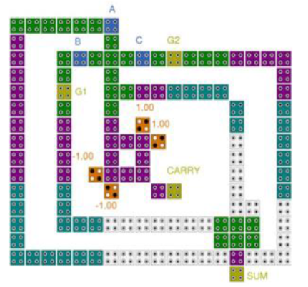
Figure 1. Proposed reversible full adder.
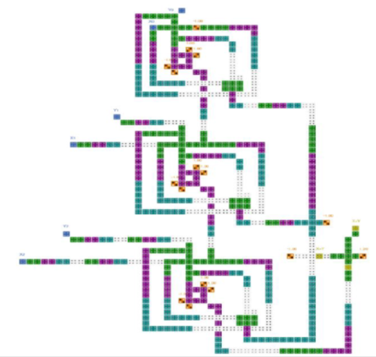
Figure 2. 3-bit comparator.
Biography
Rashmi Seethur Completed BE in Electronics and Communication from Visveswaraya Technological University in 2004. She completed her Master of Technology in VLSI and Embedded systems, 2012 with CGPA of 8.09 at UTL Technologies Limited VTU Extension Centre Bangalore. She completed her PhD in CMOS RF circuit design in 2019 from Visveswaraya Technological University. Her research interests are Analog circuit design, CMOS Amplifier design, RF circuit design and reversible logic. She has a teaching experience of about 15 years. She is a life member for IACSIT.

