Improving the fatigue design of mechanical systems such as refrigerator
Seongwoo Woo
Ethiopian Technical University, Ethiopia
Abstract
To enhance the lifetime of mechanical system such as automobile, new reliability methodology–parametric Accelerated Life Testing (ALT) [Figure 1]–suggests to produce the Reliability Quantitative (RQ) specifications—mission cycle—for identifying the design defects and modifying them. It incorporates: (1) a parametric ALT plan formed on system BX lifetime that will be X percent of the cumulated failure, (2) a load examination for ALT, (3) a customized parametric ALTs with the design alternatives and (4) an assessment if the system design(s) fulfil the objective BX lifetime. So we suggest a BX life concept, Life-Stress (LS) model with a new effort idea, accelerated factor and sample size equation. This new parametric ALT should help an engineer to discover the missing design parameters of the mechanical system influencing reliability in the design process. As the improper designs are experimentally identified, the mechanical system can recognize the reliability as computed by the growth in lifetime, LB and the decrease in failure rate. Consequently, companies can escape recalls due to the product failures from the marketplace. As an experiment instance, two cases were investigated: 1) problematic reciprocating compressors in the French-door refrigerators returned from the marketplace and 2) the redesign of Hinge Kit System (HKS) in a domestic refrigerator. After a customized parametric ALT, the mechanical systems such as compressor and HKS with design alternatives were anticipated to fulfill the lifetime–B1 life 10 year.
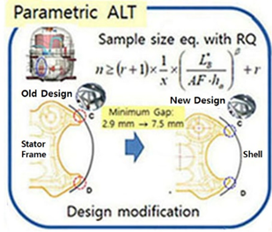
Figure 1. Schematics of Parametric ALT.
Biography
Woo has a BS and MS in Mechanical Engineering and he has obtained PhD in Mechanical Engineering from Texas A&M. He majors in energy system such as HVAC and its heat transfer, optimal design and control of refrigerator, reliability design of thermal components and failure Analysis of thermal components in marketplace using the Non-destructive such as SEM & XRAY. In 1992.03–1997 he worked in Agency for Defense Development, Chinhae, South Korea, where he has researcher in charge of Development of Naval weapon System. He was working as a Senior Reliability Engineer in Refrigerator Division, Digital Appliance, SAMSUNG Electronics. Now he is working as associate professor in mechanical department, Ethiopian Technical University.

