Synthesis of vitamin D conjugated calcium carbonate nanoparticles and their application on selected cell lines
Khazaima Shaukat
National Institute for Biotechnology and Genetics Engineering (NIBGE), Pakistan
Abstract
Cancer is a worldwide conundrum and the leading cause of death. Drug delivery to cancer cells has been changed thanks to nanotechnology. In this study, calcium carbonate nanoparticles were used to provide Vitamin D to the breast cancer cell line MCF-7. The nanoparticles that are used were prepared by using binary solvents as precipitates and swirling them continuously with a magnetic stirrer. FTIR and XRD measurements confirmed the production of nanoparticles. SEM analysis revealed that nanoparticles have a spherical morphology. According to a UV-Visible spectrophotometer, calcium carbonated nanoparticles had an encapsulation effectiveness of 80% for vitamin D. At a dosage of 2000 g/ml, vitamin D conjugated nanoparticles showed a good cytotoxic activity, reducing the viability percentage of cancer cells by up to 11%. As a result, it was found to be helpful in slowing cancer cell development. The findings showed that CaCO₃ nanoparticles can effectively supply vitamin D to cancer cells while also inhibiting cancer cell proliferation [Figure 1].
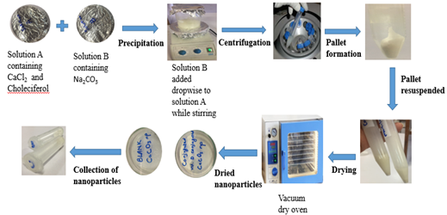
Figure 1. Synthesis of Vitamin D conjugated calcium carbonate nanoparticles.
Biography
Khazaima Shaukat is a PhD student at National Institute of Biotechnology and Genetic Engineering, Faisalabad Pakistan. This research work constitutes her MS research work. She is very passionate and brings up innovation to the research with problem solving strategy. Her expertise in synthesis of nanoparticles and her hard work to evaluate them and utilize them for solving health issues and other environmental issues make her bring uniqueness in her ideas.

