A neutrophil-related gene signature predicts immune status and sensitivity to nuclear receptor-targeting agents in triple-negative breast cancer
Muyao Wu, Lian Xue, Xi Xu, Siyu Ding, Guangchun He, Chanjuan Zheng and Xiyun Deng*
Hunan Normal University, China
Abstract
Purpose: To develop a neutrophil-related gene signature that can be used to predict survival outcomes and identify potential therapeutic drugs for Triple-Negative Breast Cancer (TNBC) patients.
Design: iTRAQ-based proteomics analysis of breast cancer tissues and bioinformatics analysis of the TCGA-BRCA dataset were performed to evaluate the pathways enriched in TNBC. Immunohistochemistry was used to determine neutrophil infiltration in TNBC. Univariate and multivariate Cox analyses were performed on TNBC patients from TCGA-BRCA dataset to derive a Neutrophil-Related Gene Signature (NRGS). A nomogram model was generated to predict survival outcomes of TNBC patients. A Gene Expression Omnibus (GEO) dataset was used for independent validation. The NRGS was analyzed for tumor immune microenvironment and response to immune checkpoint inhibitors as well as sensitivity to therapeutic drugs.
Results: Through iTRAQ-based proteomics profiling and TCGA-BRCA dataset mining, we found neutrophil-related pathways as the top enriched pathways in TNBC. A higher level of neutrophil infiltration was demonstrated by immunohistochemistry on TNBC compared with non-TNBC tissues. A 9-gene NRGS was identified and used to derive a risk score to stratify TNBC patients into high- and low-risk groups. A nomogram model with superior predicting power was generated via incorporating the NRGS with clinicopathological parameters. High-risk TNBC patients were associated with immune suppression and were less sensitive to immune checkpoint inhibitors. Furthermore, we found high-risk TNBC patients had enhanced sensitivity to nuclear receptor-targeting agents [Figure 1].
Conclusion: A neutrophil-related gene signature could predict decreased sensitivity to immune checkpoint inhibitors but increased sensitivity to nuclear receptor-targeting agents in high-risk TNBC patients.
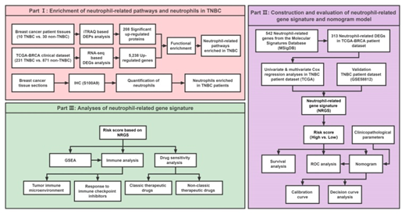
Figure 1. Part I: Enrichment of neutrophil-related pathways and neutrophils in TNBC. Part II: Construction and evaluation of neutrophil-related gene signature and nomogram model. Part III: Analyses of neutrophil-related gene signature.
Biography
Xiyun Deng is a professor of Pathophysiology, chair of Department of Basic Medical Sciences, and director of Key Laboratory of Translational Cancer Stem Cell Research at Hunan Normal University. His research focuses on experimental therapeutics targeting cancer stem cells and the tumor microenvironment. In recent years, Triple-Negative Breast Cancer (TNBC) has been a focus of intense investigations for his lab. He has published over 100 articles/reviews in high-impact professional journals such as Blood, Clinical Cancer Research, Cancer Treatment Reviews, ACS Applied Materials & Interfaces, International Journal of Cancer, Biomaterials Science, etc. He is currently guest-editing a Research Topic for Frontiers in Oncology regarding heterogeneity, tumor microenvironment and targeted therapy in triple-negative breast cancer. As a principal editor, he has compiled a book titled “Triple-Negative Breast Cancer”, which was published by World Scientific Publishing (Singapore).

