Application of transthoracic lateral single-hole non-liposuction endoscopy to immediate prosthetic breast reconstruction in early breast cancer
Chengcai Yao
South China University of Technology, China
Abstract
Statement of the problem: The quest for beauty is never-ending for women with breast cancer, so to ensure a successful treatment of the tumour, traceless surgical incisions are a consideration for surgeons. Endoscopic or robotic minimally invasive surgery may be the perfect solution to this problem, but currently endoscopic surgery is rarely performed in breast surgery for a variety of reasons, such as lack of natural space in the breast, immature technology and excessive length of operation.
Objective: The objective of this study was to investigate the efficacy of transthoracic lateral single-hole non-liposuction endoscopy in Nipple Sparing Mastectomy (NSM) with Immediate Prosthesis Breast Reconstruction (IPBR).
Methodology: The clinicopathologic data of 42 patients with EBC who underwent endoscopic NSM and IPBR in the Department of Breast Surgery of our hospital from February 2020 to July 2022 were collected and the success rate of surgery, operation time, intraoperative conditions, postoperative complications, aesthetic effect of breast reconstruction and short-term oncology safety were analyzed.
Finding: All the 42 patients successfully completed the operation, with a success rate of 100%. 12 patients were completed operation with (210.17 ± 9.87) minutes in the first year after the original procedure began and 30 patients with (155.36 ± 2.42) minutes after the first year and there was a difference between the two groups. There were also differences in intraoperative blood loss and postoperative drainage volume between the two groups, but no difference in extubation time. The postoperative complications and the aesthetic effect of breast reconstruction were not different. The 42 patients were average follow-up of 18.8 months. None of the patients had a recurrence or distant metastasis [Figure 1].
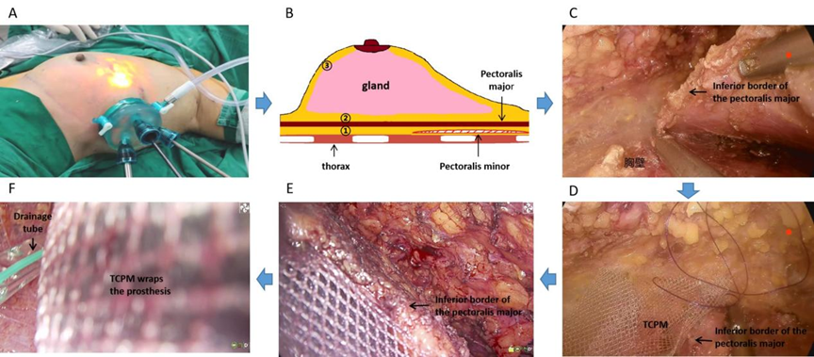
Figure 1. Flow charts of NSM and immediate breast reconstruction (A→F). (A) Shows the patient's position and lateral thoracic single-hole incision with disposable endoscopic dilator for surgery. (B) Schematic diagram of the surgical sequence of the NSM "reverse method": Posterior space of the pectoralis major→Posterior space of the breast→free flap. (C) The lower margin of the major pectoralis is surgically severed. (D) Shows the lower margin of pectoralis major and TCPM suture forming a "pouch". (E) Here is a "pouch" covering prosthesis of the pectoralis major combined with TCPM. (F) TCPM fully wrapped prosthesis with a drainage tube underneath.
Conclusions: Transthoracic lateral single-hole non-liposuction endoscopy technique for IBPR of EBC: (1) high success rate of surgery, fewer postoperative complications, good aesthetic effect and high safety of oncology; (2) Skillful practice can shorten the operation time, improve intraoperative conditions and improve surgical efficiency.
Biography
Chengcai Yao is the director and academic leader of the Department of Breast Surgery at the Sixth Affiliated Hospital of South China University of Technology, PRC. He is also a member of the breast disease branch of the Guangdong Medical Association, the breast surgery branch of the Guangdong Medical Association and the breast cancer branch of the Guangdong Anticancer Association. He is also a youthful and middle-aged editorial member of the "Chinese Journal of Breast Diseases (electronic edition)" and the "Chinese Journal of General Surgery". He is primarily engaged in basic and clinical breast cancer research, with a particular focus on minimally invasive laparoscopic surgery for early-stage breast cancer and mechanisms of drug resistance to chemotherapy.

