Vitamin A and its role in eye health: A case of severe xerophthalmia
Miriam Buenasmañanas Maeso
Hospital Universitario de Fuenlabrada, Spain
Abstract
Vitamin A is essential in the maintenance of the eye functionality and integrity. In this organ, it plays two main roles: corneal and conjunctival cells differentiation and photo transduction. A deficiency in the levels of vitamin A due to malnutrition, malabsorption or chronic alcoholism may endanger eye integrity.
We present the case of a 51-year-old woman admitted to our hospital with ataxia and red and painful right eye. She had history of chronic alcoholism and bariatric surgery ten years earlier. Wernike-Korsakoff syndrome was the first hypothesis so treatment with vitamin was initiated at that time. Ocular examination revealed a very deep peripheric ulcer with sharp edges and a 2 mm hypopyon. Conjunctival culture and Gram stain were performed and treatment was started with topic tobramycin and ciprofloxacin, corticoid boluses and oral moxifloxacin, doxycycline and ascorbic acid. Over the next three days hypopyon resolved but the corneal thinning progressed so multi-layered amniotic membrane transplantation was performed. The culture was negative and the exhaustive systemic study performed showed vitamin A deficiency as the only finding, so supplementation was initiated. The corneal condition began to improve substantially since the amniotic membrane transplantation and two months later the corneal thickness exceeded 400 microns, with best-corrected visual acuity of 0,7 [Figure 1].
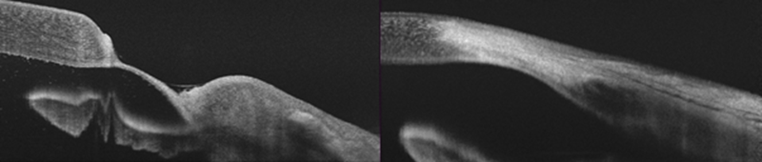
Figure 1. Anterior segment optical coherence tomography: Before amniotic membrane transplantation and two months after.
Biography
Miriam Buenasmañanas Maeso is a Spanish ophthalmologist whose first interest is to bring the best to her patients. Always eager to learn and to improve her skills, nowadays she works in the public health system in the specialty of cornea and anterior segment. With her mantra “what is not known cannot be diagnosed”, she tries to be the best version of herself.

