The efficacy of using oral doxycycline along with intravitreal bevacizumab injection in diabetic patients with clinically significant macular edema medical science
Niusha Kasiri, Ali Kasiri, Fereydoun Farrahi, Mohammad Sadegh Mirdehghan* and Rozhin Kasiri
Ahvaz Jundishapur University of Medical Sciences, Iran
Abstract
Background: With advances in medical facilities and increased survival of premature infants, the prevalence of Retinopathy of Prematurity (ROP) has increased. This study aimed to determine the frequency of ROP and its associated risk factors.
Methods: This descriptive-analytical, retrospective study included all premature infants with a Birth Weight (BW) ≤ 2,500 g and/or Gestational Age (GA) ≤ 35 weeks who were referred to Imam Khomeini Hospital in Ahvaz, Iran, for ROP screening over a 7-year period from April 2013 to April 2020. Demographic criteria, associated risk factors and findings of eye examinations were collected and analyzed.
Results: Of the 812 at-risk infants screened, 807 met the inclusion criteria. ROP was observed in 316 (39.0%) of the 807 premature infants, with types I and II in 142 (45.0%) and 174 (55.0%) infants, respectively. The mean GA (29.6 {2.5 weeks versus 30.7} 2.5 weeks) and BW (1,203.6 {382.8 g versus 1,333.5} 386.5 g) were significantly lower in infants with ROP than in those without ROP (both P<0.001). GA (r=0.80; P<0.001) and BW (r=0.85; P<0.001) had a strong positive correlation with ROP and the correlation increased as GA and BW decreased (all P<0.001). Associated risk factors in infants with ROP, in order of frequency, were oxygen therapy (22.8%), respiratory distress (16.1%), phototherapy (14.6%), blood transfusion (5.7%), apnea (4.1%), mechanical ventilation (1.6%) and intraventricular hemorrhage (0.9%). Multivariate regression analyses showed low GA and BW (both P<0.05) as independent predictors of ROP [Table 1].
Table 1. Correlation between retinopathy of prematurity and gestational age in premature infants.
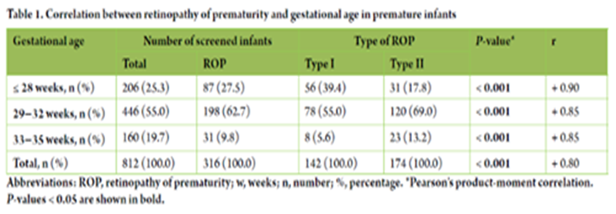
Conclusions: The frequency of ROP in premature infants was slightly higher than the average range reported for domestic and foreign statistics. Low BW and GA were independent predictors of ROP.
Keywords: Low birth weight, Premature infant, Retinopathy of prematurity, Frequency, Risk factors, Oxygen therapy, Respiratory distress, Phototherapy, Blood transfusion, Apnea, Mechanical ventilation, Intraventricular hemorrhage.
Biography
Mohammad Sadegh Mirdehghan studied electrophysiological methods including ERG (Electro retinography), VEP (Visual evoked potential) & EOG (Electro oculography) in early diagnosis of several ophthalmological disorder like amblyopia, optic neuritis in MS suspected patients or chemical weapon injured patients and also he studied comparison, efficacy and accuracy of these tests in diagnosis of different ophthalmological diseases causing visual disturbance. At the department of radiology (Frankfurt, Germany) he was studying several methods of drug delivery to tumors of lung and liver specifically using chemoembolization and microwave ablations and also radiological interventional methods for treatment of orbital tumors and vascular anomalies. Several research articles proceed and have been published during his post graduate courses.

