Selective GSK3β inhibition mediates an Nrf2-independent anti-inflammatory microglial response
Mohamed H. Yousef, Mohamed Salama, Hassan A. N. El-Fawal and Anwar Abdelnaser*
The American University in Cairo, Egypt
Abstract
Glycogen Synthase Kinase 3 (GSK3) is associated with the proinflammatory phenotype of microglia and has been shown to act in concert with nuclear factor kappa B (NF-κB). GSK3 is also a suppressor of Nuclear factor erythroid 2-related factor 2 (Nrf2), the principal regulator of redox homeostasis. Agreeing with the oxidative paradigm of aging, Nrf2 is often deregulated in Para inflammatory and neurodegenerative diseases. In this study, we aimed to explore a multimodal disease-modifying utility of GSK3 inhibition, beyond neuronal proteopathologies. Furthermore; we aimed to underscore the difference in therapeutic value between the two GSK3 paralogs by isoform-selective chemical inhibition.
The anti-inflammatory effects of paralog-selective GSK3 inhibitors were evaluated as a function of the reductive capacity of each to mitigate LPS-induced activation of SIM-A9 microglia. The Griess method was employed to detect the nitrate-lowering capacity of selective GSK3 inhibition. Real-time PCR was used to assess post-treatment expression levels of pro-inflammatory markers and antioxidant genes; pro- inflammatory cytokines were assayed by ELISA. Nuclear lysates of treated cells were examined for Nrf2 and NF-κB accumulation by immunoblotting. Finally, to infer whether the counter-inflammatory activity of GSK3 inhibition was Nrf2-dependent, DsiRNA-mediated knockdown of Nrf2 was attempted.
Results from our experiments reveal a superior anti-inflammatory and anti-oxidative efficacy for GSK3β-selective inhibition, compared to GSK3α-selective and non-selective pan-inhibition; hence use of selective GSK3β inhibitors is likely to be more propitious than non-selective dual inhibitors administered at comparable doses. Moreover, our results suggest that the anti-inflammatory effects of GSK3 inhibition are not Nrf2 dependent.
Keywords: GSK3, Paralog selectivity, Microglia, Neuroinflammation, Neurodegenerative diseases, Oxidative stress, Nrf2, NF-κB.
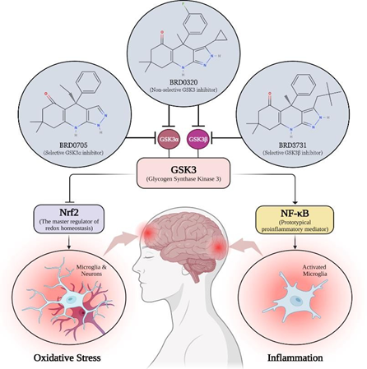
Figure 1. Selective GSK3β inhibition mediates an Nrf2-independent anti-inflammatory microglial response.
Biography
Abdelnaser is an assistant professor of chemistry at the School of Science and Engineering of The American University in Cairo. Abdelnaser received his bachelor of pharmacy (B Pharm) degree from Ajman University, Ajman, United Arab Emirates in 2006 and his MSc and PhD from the University of Alberta, Edmonton, Alberta, Canada in 2008 and 2013, respectively. Following this, he worked as a post-doctoral associate at the University of Alberta for three years. During his graduate and post-doctoral studies, Abdelnaser received several universities, provincial and federal awards and scholarships. He has published over 40 peer-reviewed articles in international journals and a similar number of abstracts in local, regional, international meetings and conferences.

