Crystal-array-assisted growth of a perovskite absorption layer for efficient and stable solar cells
Zhichao Shen
Shanghai Jiao Tong University, China
Abstract
The photovoltaic performance and stability of Perovskite Solar Cells (PSCs) are closely related to the quality of the absorption layer. Further improving the crystallinity of perovskite films is of great significance for the commercial application of PSCs. Here, we introduce a Perovskite Crystal Array (PCA) with regular distribution to assist the growth of the perovskite absorption layer. The PCA provides nuclei where the crystallization can commence without overcoming the critical Gibbs free energy for nucleation and induces a controllable bottom-up crystallization process under solvent annealing. As a result, a perovskite film with high crystallinity and reduced grain boundaries was obtained. The largest grain size was over 4 microns and the average grain size was over 3 microns. PSCs based on the perovskite film with the PCA achieved power conversion efficiencies of 25.1% (certified 24.3%) and 23.1% (certified 22.3%) with aperture areas of 0.0784 cm² and 1.0085 cm², respectively. The devices maintained 90% of their initial efficiency after operation at the maximum power point for 2000 hours [Figure 1].
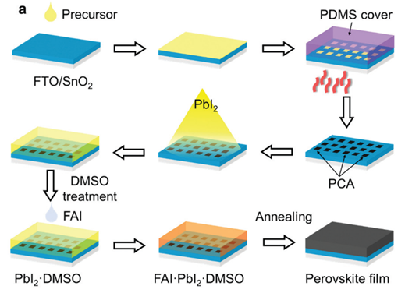
Figure 1. Schematic of the fabrication procedure of the perovskite crystal array, thermal evaporation and PCA-assisted growth.
Biography
Zhichao Shen obtained his bachelor’s degree in materials science and engineering at Hunan University (China) in 2018 and then continued his study at Shanghai Jiao Tong University for a doctorate degree. His current research is focused on fabricating highly efficient and stable perovskite solar cells through compositional engineering, interface modification and structure innovation.

