Human nanomedicine: Nanomaterials in the clinic
Thomas J. Webster
Hebei University of Technology, China
Abstract
Nanomaterials have been widely tested in vitro and in small order animal studies for decades. Results have shown greater tissue growth, decreased bacteria growth and inhibited inflammation. However, few studies exist examining human tissue response to nanomaterials. This presentation presents a cohort study of nano implants inserted into humans. In particular, one study includes the implantation of nanotextured spinal implants into over 14,000 patients over the past 5 years. Results demonstrated no cases of infections or other implant failures which is significantly better than statistics on conventional spinal implants which have up to 20% failure rates. This study will further explain that nano implants mimic the natural nano texture of bone itself and possess surface energy that can competitively increase the adsorption of proteins known to promote osteoblast (bone forming cells) functions, decrease bacteria functions and limit inflammatory cell functions. As such, this presentation will cover the few human clinical studies on nano implants showing improved human health [Figure 1].
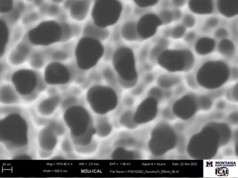
Figure 1. Titanium implant modified to have nanoscale surface features.
Biography
Thomas J. Webster’s (H index: 114; Google Scholar) degrees are in chemical engineering from the University of Pittsburgh (B.S., 1995; USA) and in biomedical engineering from RPI (PhD, 2000; USA). He has served as a professor at Purdue (2000-2005), Brown (2005-2012) and Northeastern (2012-2021; serving as Chemical Engineering Department Chair from 2012-2019) Universities and has formed over a dozen companies who have numerous FDA approved medical products currently improving human health. He is currently helping those companies and serves as an adjunct professor at Hebei University of Technology, Saveetha University, Vellore Institute of Technology, UFPI and others. He has numerous awards including: 2020, World Top 2% Scientist by Citations (PLOS); 2020, SCOPUS Highly Cited Research (Top 1% Materials Science and Mixed Fields); 2021, Clarivate Top 0.1% Most Influential Researchers (Pharmacology and Toxicology); 2022, Best Materials Science Scientist by Citations (Research.com); and is a fellow of over 8 societies. He has over 1,350 publications to his credit with over 53,000 citations.

