Magnesium ascorbyl phosphate vesicular carriers for topical delivery; preparation, in-vitro and ex-vivo evaluation, factorial optimization and clinical assessment in melasma patients
Soha M. Kandil¹*, Iman I. Soliman², Heba M. Diab³, Nermeen I. Bedair⁴, Marwa H. Mahrous¹ and Ebtsam M. Abdou^{1,5}
¹Modern University for Technology and Information, Egypt
²Cairo University, Egypt
³Ain Shamas University, Egypt
⁴Helwan University, Egypt
⁵National Organization of Drug Control and Research (NODCAR), Egypt
Abstract
Ascorbic acid (vitamin C) is an antioxidant that is widely used in cosmetics in skincare products. Due to the excessive low stability of ascorbic acid in cosmetic formulations, the stabilized ascorbic acid derivative, Magnesium Ascorbyl Phosphate (MAP) was formulated as vesicular carriers; ethosomes and niosomes. The aim was to deliver MAP at the intended site of action, the skin, for sufficient time with enhanced permeation to get an effective response. Ethosomes were formulated using a full 3² factorial design to study ethanol and phospholipid concentration effect on ethosomes properties. Niosomes were formulated using 2³ factorial designs to study the effect of surfactant type, surfactant concentration and cholesterol concentration on niosomes properties. The prepared formulations were evaluated for their Entrapment efficiency, particle size, polydispersity index, zeta potential and % drug permeated. The optimized ethosomal and niosomal formulations were incorporated into carbopol gel and evaluated for their permeation, skin retention and stability. A comparative split-face clinical study was done between the ethosomal and niosomal formulations for melasma treatment using Antera 3D® camera [Figure 1]. The optimized ethosomal and niosomal gels showed comparable controlled permeation and higher skin retention over their ethosomes and niosomes formulations respectively. Magnesium ascorbyl phosphate ethosomal gel showed clinically and statistically significant melanin level decrease after one month while MAP niosomal gel showed clinically and statistically significant melanin level decrease after six months. A combination of MAP ethosomes and niosomes could be promising skin care formulations for melasma and hyperpigmentation short and long-term treatment.
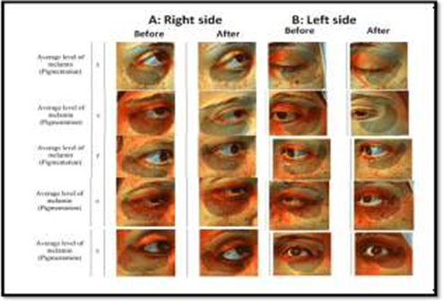
Figure 1. Samples of Antera 3D® Camera photos of before and after treatment with: (A) Right side (MAP niosoma gel) and (B) Left side (MAP ethosoal gel).
Biography
Soha Mohamed abd Elmnem Kandil is an Associate Professor of Pharmaceutics and Industrial Pharmacy and lecturer Clinical Pharmacy with over 15 years of experience. Her Areas of Research: Advanced in vivo research including experimental animals & patients at New Kasr El Ainy Teaching Hospital, Cairo University and Controlled release systems for solid dispersions, Self-Micro-Emulsifying Drug Delivery System (SMEDDS) and Nanoparticles as liposomes or niosomes and ethosome and Tran-novasomes.

