Immobilizing lipase on hydrophobic wrinkled silica nanoparticles from a water/oil mixture as a strategy to induce hyperactivation
Valeria Califano
Institute of Sciences and Technologies for Sustainable Energy and Mobility (STEMS), Italy
Abstract
Wrinkled Silica Nanoparticles (WSNs) with central-radial pore structure were hydrophobized by chemical vapor deposition of perfluorodecyltriethoxysilane (PDTES): surface functionalization was used to design a hydrophobic surface to induce interfacial activation of lipase by lid opening. In fact, lipases are unique often require interfacial activation for full catalytic performance. Actually, since lipids are water insoluble, lipases act on emulsified systems. Upon adsorption at a hydrophobic/hydrophilic interface, lipase undergoes a conformational change from the inactive to the active conformation. This change is promoted by the movement of a helical loop from the ‘closed’ form in which the catalytic site is inaccessible to the ‘open’ active one. To further modulate the closed/open form equilibrium, n-hexane was added to the water/lipase solution, creating a micro-oily environment [Figure 1].
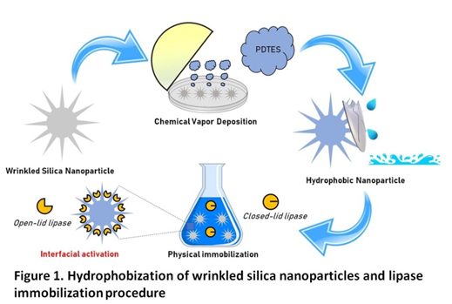
Figure 1. Hydrophobization of wrinkled silica nanoparticles and lipase immobilization procedure.
Three different supports were prepared, varying the degree of hydrophobicity. The effect of the different hydrophobicity and of the addition of n-hexane on the adsorption of lipase was evaluated. The best biocatalyst obtained was tested in the transesterification of sunflower seed oil to produce biodiesel, showing hyperactivation. The reaction yields were 93% for the immobilized enzyme and 56% for the free one. The results suggest that both the hydrophobicity of the support and the addition of n-hexane favor the adsorption of lipase in the active conformation.
Methodology: Physicochemical characterization of supports was carried out by solid state 29Si Nuclear Magnetic Resonance (NMR), the Brunauer–Emmett–Teller (BET) method, Thermo-Gravimetric (TG) analysis, Contact Angle (CA) measurement, Scanning Electron Microscopy (SEM) and Fourier Transform Infrared (FT-IR) Spectroscopy.
Biography
Valeria Califano Graduated in Industrial Chemistry at the University of Naples Federico II, She obtained her doctorate in 2005 at the Laboratoire de Physico-Chimie des Matériaux Luminescents (LPCML) at Claude Bernard Lyon University, France. The PhD thesis focused on the "Structural study of oxide-based glasses for non-linear optics: growth of nanostructures and the effect of an electric field ('poling')." From 2006 to 2009 she worked as a research fellow in the Applied Optics laboratory of the Ettore Pacini Department of Physics, at the Federico II University of Naples. In 2009 she won a scholarship at the then Istituto Motori (CNR), now STEMS, where she became a researcher in 2011. Her research field ranges from the immobilization of enzymes for the production of liquid biofuels, to CO₂ capture by hybrid materials based on mesoporous silica and amines, laser deposition of thin films and formulation, characterization and analysis of the combustion of water/oil emulsions.

