Quasi two-dimensional CeVO₄ nanozyme: Fabricated through non-oxidic material
Kuldeep Kumar¹*, Tanmoy Maity², Leela S. Panchakarla¹ and Siddarth Jain¹
¹Indian Institute of Technology Bombay, India
²Indian Institute of Science Education and Research Kolkata, India
Abstract
In recent years, the synthesis of materials in lower dimensions like Two-Dimensional (2D) or quasi-2D with distinctive characteristics has attracted substantial scientific attention. The Mixed Transition Metal Oxides (MTMOs) nanomaterials are the promising group of materials which have been extensively utilized for various potential applications. The most of the MTMOs explored as Three-Dimensional (3D) nanospheres, nanoparticles, and One-Dimensional (1D) nanorods, nanotubes. However, these materials are not well explored in 2D morphology because of the difficulties in removing tightly woven thin oxide layers or exfoliations of two-dimensional oxide layers hindering the exfoliation of beneficial features of MTMO. Here, we demonstrated the fabrication of CeVO₄ Nano Sheets (NS) from non-oxidizing materials using a simple two-step synthesis process. The as-synthesized CeVO₄ NS exhibit adequate stability and activity in a harsh reaction environment, which gives excellent peroxidase-mimicking activity with a KM value of 0.04 mM, noticeably better than natural peroxidase and previously reported CeVO₄ nanoparticles. We have also used this enzyme mimic activity for the efficient detection of biomolecules like glutathione with a LOD of 53 nM [Figure 1].
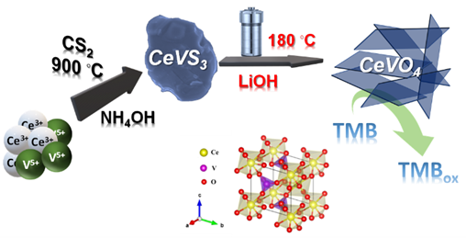
Figure 1. Schematic representation.
Biography
Kuldeep Kumar received his master’s in chemistry from CSJM University Kanpur, India in 2017. Then he enrolled in PhD under Late Prof. Leela Srinivas Panchakarla at IIT Bombay, India since 2018. Currently he is working under the supervision of Prof. Sanjog S. Nagarkar. His research topic is synthesis of lanthanide-based metal oxides and sulphides nanoarchitectures and their multifunctional applications in electronics and catalysis.

