The association between intravenous solutions induced hyperchloremia, metabolic acidosis and new or progressive acute kidney injury among pediatric patients with diabetic ketoacidosis: A retrospective cohort study
Joan Christine S. Guina
DPPS Philippine Children’s Medical Center, Philippines
Abstract
Statement of the problem: Diabetic Ketoacidosis (DKA) requires immediate fluid resuscitation. Excessive administration of high chloride containing IV fluids can cause hyperchloremia. Currently, there is scarcity of data associating hyperchloremia with Acute Kidney Injury (AKI) and prolonged metabolic acidosis among children with DKA. This study aimed to investigate the association between intravenous solutions induced hyperchloremia, metabolic acidosis and AKI among DKA patients.
Methodology: This is a retrospective cohort study among cases of Diabetic Ketoacidosis. The serum chloride levels were reviewed; the total chloride infused was computed and compared per time interval by repeated measures ANOVA. Hyperchloremic cases were determined and were analyzed for the occurrence and association with acute kidney injury using Fisher exact test. The serum chloride, total chloride infused, total fluid input and urine output among those with and without AKI were evaluated. The length of DKA resolution was compared among the hyperchloremic and non-hyperchloremic group.
Results: There were 167 eligible cases of DKA. 158 (94.6%) of these developed hyperchloremia and 36 (21%) had AKI. The association between hyperchloremia and AKI is not statistically significant (P=0.21) but a significant decreased in urine output among the cases was proven (P=0.008). The length of DKA resolution by closure of anion gap has an average of 21.29 ± 13.95 hours while the rise of pH has 25.51 ± 14.77 hours and 29.7 ± 14.89 hours for HCO₃ level (Figure 1). Hyperchloremic group has longer duration of DKA resolution by pH (P=0.0281) and bicarbonate (P=0.0080) while no statistical difference was noted for the closure of anion gap between the two groups.
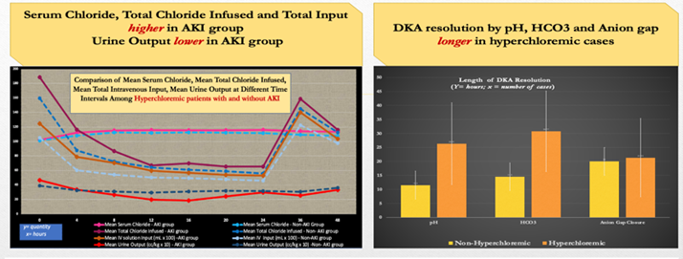
Figure 1. Comparison of mean serum chloride, mean total chloride infused, mean total IV input and mean urine output at different time intervals among hyperchloremic and non-hyperchloremic group. Comparison of length of DKA resolution by pH, HCO₃ and closure of anion gap among Hyperchloremic and non-hyperchloremic group.
Conclusion: Hyperchloremia (95%) is common during fluid resuscitation. It causes prolonged metabolic acidosis and decreased urine output which leads to acute kidney injury. Recommendation: Lower chloride containing solutions must be used to prevent hyperchloremia especially in the critically ill to prevent its adverse effect.
Biography
Joan Christine Guina is a General Pediatrician who opted to undergo training in Pediatric Nephrology. She is now a diplomate and has recently started practicing as a Pediatric Nephrologist in the Philippines. She has always aimed to improve the health care delivery in their community and hopes to reach the underserved children with kidney diseases.

