Comparison of outcomes of erythropoietin beta and erythropoietin alpha for treatment of anemia in children with chronic kidney disease on maintenance hemodialysis: A retrospective cohort study
Phoebe Anne M. Dino-Santos*, Rachelle C. Dela Cruz, Caridad M. Santos and Angelo Martin B. Catacutan
Philippine Children's Medical Center, Philippines
Abstract
Statement of the problem: Anemia is a common complication of chronic kidney disease that can be treated with Erythropoietin. This study aims to compare the outcomes of Erythro-Poietin Alpha (EPO A) and Erythro-Poietin Beta (EPO B) in children on maintenance hemodialysis [Table 1].
Table 1. Comparision of treatment outcomes between EPO A and EPO B during treatment and maintenance phase among children with CKD on maintenance hemodialysis.
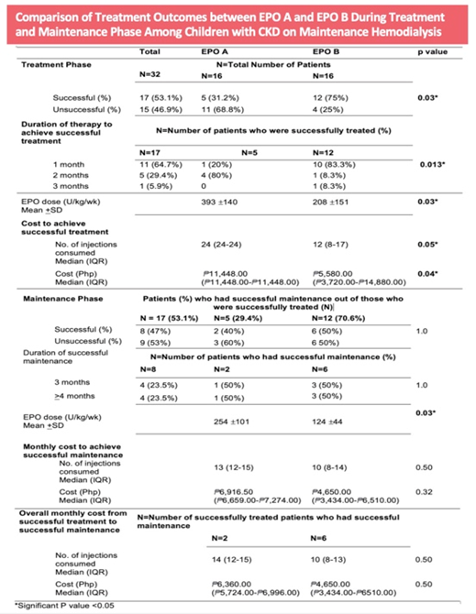
Methodology & theoretical orientation: This is a retrospective study involving hemodialysis patients aged 12 to <19 years old with Hemoglobin (Hb) >8 to <11 g/dL. Patients were grouped according to the type of EPO they received. Successful treatment was defined as achievement of Hb>11 g/dL within 3 months of treatment and successful maintenance as Hb>11 g/dL for >3 months after successful treatment. The effectiveness and treatment cost using EPO A and EPO B were compared.
Findings: Thirty-two subjects were included, sixteen for each EPO group. A higher percentage of successful treatment (75% vs. 31.2%, P=0.03; AOR 0.07 95% CI: 0.01-0.71) and maintenance (50% vs. 40% p=1.0) were observed in EPO B compared with EPO A. Lower doses of EPO B were required for successful treatment (208 ± 151 vs. 393 ± 140, P=0.03) and maintenance (P=1.0). The median increase of Hb using EPO B was higher (P=0.002) after 1st month. Hypertensive episodes were similar in both groups. A lower cost of EPO B was computed for successful treatment (P=0.04) and maintenance (P=0.32).
Conclusion: This study has shown that EPO B is more effective than EPO A in the management of anemia among children on maintenance hemodialysis. Both EPOs have comparable safety profiles. This is the first study that directly compares EPO A and EPO B in children and prospective studies may be done to reinforce these findings.
Biography
Phoebe Anne M. Diño-Santos is a Diplomate in Pediatric Nephrology. Her passion for research writing led her to pursue further training in Clinical Research. She wishes to advance her knowledge in the field of research and write outstanding research papers that can contribute to the development and improvement of children’s health.

