Black mulberry (Morus nigra) fruit extract alleviated AD-Like symptoms induced by toxic Aβ protein in transgenic Caenorhabditis elegans via insulin DAF-16 signaling pathway
Yan Liu
Lanzhou University, China
Abstract
Alzheimer’s Disease (AD) is one of the most severe neurodegenerative disorders. Recently, there is no effective treatment drug for AD. Morus nigra (M. nigra) is a black mulberry and widely distributed fruit in the Moraceae family with various undiscovered biological activities. The study aimed to investigate the potential anti-AD effect of M. nigra. Mulberry Fruit extract (MF) was obtained from M. nigra and treated up to 1.00 mg/mL on transgenic AD Caenorhabditis elegans (C. elegans) models. MF inhibited Amyloid-β (Aβ)-induced paralysis symptoms by about 55.65 %, reduced Aβ accumulation more than 50% via immunoblotting and suppressed over-sensitivity to exogenous serotonin in C. elegans. Furthermore, MF decreased the Aβ oligomeric depositions in worm CL2006. MF activated the DAF-16 nuclear translocation and its downstream SOD-3 and GST-4. AD is a major age-related disorder. Therefore, MF treated or an aging test and proved to be expanded the lifespan of the worms up to 34.7%. Besides, we have evaluated the MF in vivo antioxidative properties, where MF reduced Reactive Oxygen Species (ROS) generations in C. elegans and remitted the activation of HSP-16.2 induced by the oxidative action of Juglone. Gene knockout and extended the lifespan of AD worms. However, RNA interference (RNAi) successfully silenced the daf-16 on the Aβ phenotypic paralysis proved by MF effect. Our results indicate that MF alleviates AD-Like symptoms by activating the DAF-16 insulin signal pathway in C. elegans. Therefore, this MF study may provide new insights for mulberry application in safe AD treatment and clinical study [Figure 1].
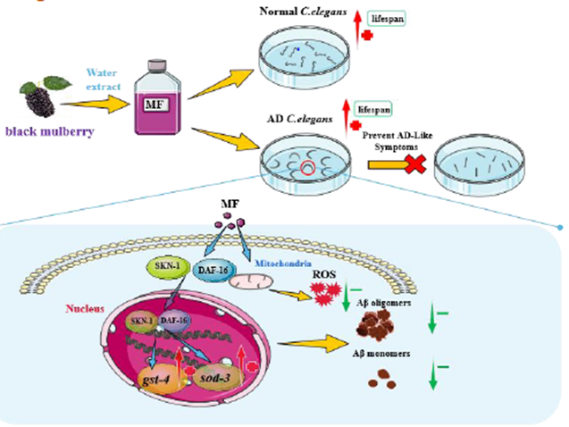
Figure 1. Graphical abstract.
Biography
Yan Liu has completed her PhD from Lanzhou University and postdoctoral studies from Massachusetts General Hospital, Athinoula A. Martinos Biomedical Imaging Center. She is also a Lecturer at the School of Pharmacy, Lanzhou University. She has published more than 20 papers in reputed journals that have been cited over 70 times.

