Bullfighting trauma
Andreu Martinez Hernandez
University General Hospital of Castellon, Spain
Abstract
Background: Although bullfighting festivals were traditionally attributed to the cultural idiosyncrasies of the Ibero-American people, they also exist world-wide. The province of Castellon (Valencian Community, Spain) is considered one of the regions with the most bull-related activities worldwide, with more than 5,000 popular events held every year. The objective of this study was to present our experience in the integral care of patients injured by bull horns, describing the characteristics of this type of injury and its possible complications.
Methods: A retrospective study was conducted, reviewing the medical records of patients treated on our service for bull horn injuries between January 1978 and December 2019.
Results: There were 572 admissions due to bull horn injuries. 54 of these patients had multiple injuries. The average annual admission was 13.6 patients. The most frequent injuries were located in the lower extremities, perineum and abdomen. Forty-seven laparotomies were performed, revealing intra-abdominal visceral impairment on 39 occasions. The most frequently injured organs were the intestine and liver. The most frequent complications were skin devitalisation, infection and post-operative eventration. The recorded mortality was 0.87% (Figure 1).
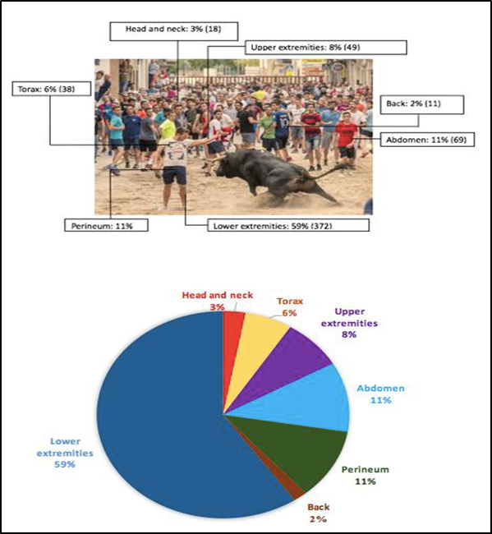
Figure 1. Results.
Conclusion: We wish to highlight the importance of injuries caused by bull horns worldwide. These are high-impact injuries with specific intrinsic characteristics that require regulated medical and surgical care.
Biography
Andreu Martinez Hernandez Graduated in Medicine from the Catolic University of Valencia, Spain. He is a General and Digestive Surgeon. He completed his masters in the University in General and Digestive Surgery. He completed Master University in trauma and bullhorn injuries. He completed Master University in Obesity Surgery. He did Training Fellowship in Trauma and Acute Care Surgery at Sotero del Rio Hospital, Santiago de Chile. He is a consultant in Endocrine, Bariatric and Metabolic Surgery at University General Hospital of Castellon, Spain. The scientific research was in line with this addressing various areas of investigation, including general surgery and emergency trauma care, specifically to trauma and bullhorn injuries studies.

