Regeneration of tissues from vascular smooth muscle cells
Yoshihiro Ishikawa
Yokohama City University, Japan
Abstract
A major disadvantage of synthetic arterial grafts is the lack of elasticity. Co-presence of thrombogenicity of synthetic grafts also increased the interest in the development of tissue-engineered vascular grafts. We have developed a method for generating scaffold-free elastic arterial grafts from cultured vascular smooth muscle cells. Those cells were treated by periodic exposure to high pressure during repeated cell seeding. Slow cycles between atmospheric and high pressure promoted fibronectin fibrillogenesis and cellular self-assembly, leading to the generation of multilayered cell-based grafts. Our engineered grafts were highly elastic, and the tensile rupture strength was similar to that of endogenous ones. Therefore, the patch of such medial grafts was sutured at the rat aorta. The patch was fully endothelialized without thrombosis. Similarly, tubular medial constructs were implanted in rats as aortic grafts, which well tolerated with arterial blood pressure and remained functional. We also developed a multilayered human skeletal muscle myoblast sheet generated similarly, i.e., periodic exposure to supraphysiological hydrostatic pressure during repeated cell seeding. We assessed whether the application of such a sheet can promote the healing process after colonic anastomosis. Partial colectomy and insufficient suturing were employed to create a high-risk colo-colic anastomosis model in rats. We found that the application of our sheet significantly suppressed abscess formation at the anastomotic site compared to the control group. We also found that the anastomotic bursting pressure was higher than that in the control group. Inflammatory cell infiltration was significantly suppressed compared to that in the control group. Collagen deposition was significantly abundant compared to that in the control group. Regeneration of the mucosa at the colonic anastomotic site was promoted. Putting together, our novel organized self-assembly method should enable mass production of scaffold-free elastic grafts in vitro for using in cardiovascular or gastrointestinal repair [Figure 1].
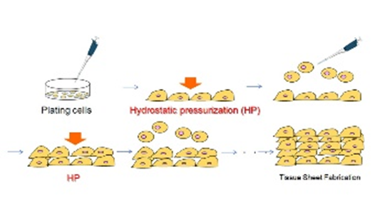
Figure 1. Tissue regeneration from cultured cells. Cells were exposed to periodic hydrostatic pressure and cultured in layers. The resultant cell layer sheets were used for fabrication of artery or colon tissues.
Biography
Yoshihiro Ishikawa received his MD from Yokohama City University. He established his laboratory at Columbia University in 1991, and moved to Harvard, where he published multiple papers on the identification of cardiac adenylyl cyclase, which is now known as type 5 and 6 isoforms. He also developed the transgenic mouse model that overexpresses Gs in the heart using the myosin heavy chain promoter. This was the first transgenic model with cardiac overexpression changing its function. He has conducted numerous studies in the field of cAMP signal, from the beta-adrenergic receptor to the EP4 receptor. He is also interested in developing collaboration with scientists of engineering, physics or chemistry. He worked as Professor of Cell Biology and Medicine and attending physician of cardiology at the Rutgers University until 2011. He is currently the Chair of the Cardiovascular Research Institute of Yokohama City University.

