The role of COVID-19 on the mental and physical health of pregnant or non-pregnant mothers of young children in food insecure households
Aylin G. Galvan* and Connie S. Ruiz
Lamar University, USA
Abstract
The purpose of this study was to ascertain the prevalence and effects of food insecurity on a specific sample of participants during the COVID-19 pandemic. The data were collected by using a questionnaire completed by participants who were pregnant, lactating, or mothers of living children during the COVID-19 pandemic. Collected data were used to analyze differences in food insecurity between pregnant and non-pregnant women and to investigate the perceptions of study participants regarding effects on pregnancy from food insecurity and the pandemic. Participants were asked about their race/ethnicity, level of education, physical characteristics, financial situation, food insecurity status, if they were diagnosed with COVID-19, experiences of mental disorders, and more [Figure 1]. All observed demographic variables were shown to have been significant in the prevalence of food insecurity amongst maternal individuals: ethnicity, race, level of education, annual income, COVID-19 status, and Body Mass Index (BMI). The present study focused on childbearing women who were in their reproductive years and current mothers, and how they coped with the challenges of COVID-19 financially, emotionally, and physically. The COVID-19 pandemic has only been a part of our lives for almost three years; although a grand amount of research has been done to lower the cause and spread of the virus, much research still needs to be done on the demands of women made by such a worldwide tragedy. Future pandemics will occur as they have done so in past decades; further research can be done to make necessary changes in lowering food insecurity rates amongst more food- insecure individuals. Such changes may include increased nutrition education levels, stay-at-home kits, or virtual visits [Figure 2].
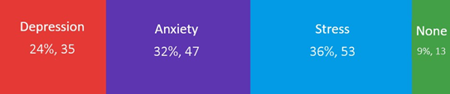
Figure 1. Mental symptoms experienced by participants.
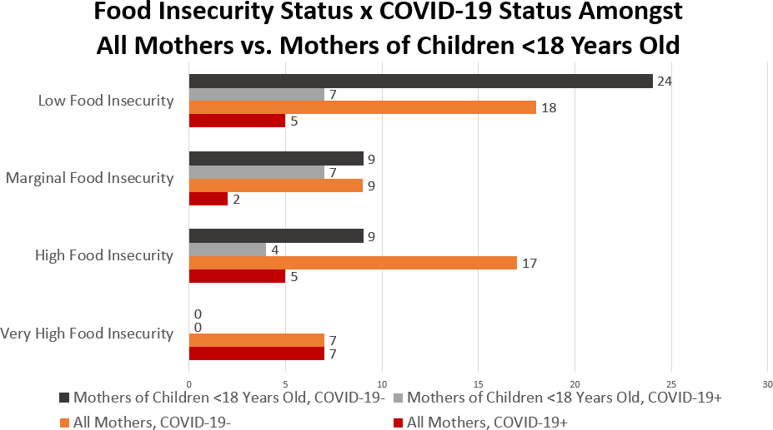
Figure 2. COVID-19 status amongst participants.
Biography
Aylin Galvan has gained her research experience through the Ronald E. McNair Post-Baccalaureate Achievement Research Program at Lamar University and the Cyclone Scholars Summer Research Experience at Iowa State University. She has demonstrated a passion for improving the health of lower income individuals such as current or expecting mothers, infants, and children through nutritional wellness and targeting areas of food insecurity. She has gained experience in spreading nutrition education to various populations including fellow classmates, underclassmen, high schoolers, and children in order to encourage healthier dietary habits and reduce prevalence of food insecurities through lack of nutritional knowledge. She is currently enrolled in her fourth and final year of undergraduate in Lamar University, on track to earn her Bachelors of Science in Nutrition with plans to pursue a Master’s of Science and PhD in Nutrition.

