Nutritional composition of isolates from solojo cowpea (Vigna unguiculata L. Walp) and its potential as a safer food substitute to animal protein source for better health
Chibudike O. Henry
Federal Institute of Industrial Research Oshodi, Nigeria
Abstract
Public health is the science of protecting and improving the health of people and their communities. This is achieved by promoting healthy lifestyles, researching disease and injury prevention and detecting, preventing and responding to infectious diseases. Food and nutrition have significant implications for the health and well-being of society. Both food and nutrition are matters of Public Health because food and nutrition are closely related to health. There is strong evidence that links a healthy diet with optimal growth and development such as improved infant, child and maternal health, stronger immune systems, safer pregnancy and childbirth, lower risk of non-communicable diseases (such as diabetes, cardiovascular disease, obesity, osteoporosis, cognitive decline and certain types of cancer), high educational attainment and longevity. Nutrition is about eating a healthy and balanced diet. Food and drink provide the energy and nutrients you need to be healthy. Understanding these nutrition terms may make it easier for you to make better food choices. Most people in the United States don't eat a healthy diet and consume too much sodium, saturated fat and sugar, increasing their risk of chronic diseases. These are the three biggest nutrition related challenges to public health. Large amounts of saturated fat and cholesterol amongst others are problems associated with animal protein sources. The water and energy resources needed for the creation of animal protein is very high compared to plant-based protein production. Nowadays, concerns about high-cholesterol and growing awareness about nutritional dependent ailments, has made consumers more conscious in their food selection thus making plant protein to be preferred. The excessive price of protein from animal origin has induced the increasing excitement in utilization of plant protein industrially both in edible and non-food market with special interest in legumes. Economic growth and global food security now depend on a dwindling number of plant species. In human history, more than 4,000,000 plant species have been identified as having potential to be used as food, shelter, fibers, industrial, cultural and medicinal plants. Unfortunately, barely a handful of these plants are widely utilized. The remaining plant diversity is underutilized and gradually going into extinction. This research paper will seek to explore how food and nutrition can promote health, quality of life and economic prosperity. It will also explore nutrition-related health issues and challenges, across the globe, from infancy through adulthood. Malnutrition, food insecurity and hunger all too often occur within the same communities and households. The relationship among malnutrition, food security, hunger and health, incorporating the four pillars of food availability, access, utilization and stability, will be used in assessing and developing strategies that accelerate progress toward optimal health [Figure 1].
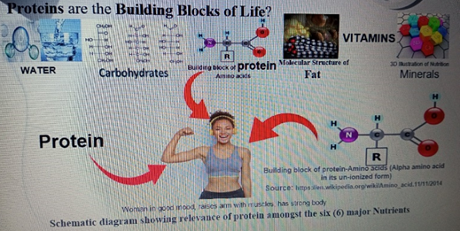
Figure 1. Schematic diagram showing relevance of protein amongst the six (6) major nutrients.
Keywords: Public health, Nutrition, Animal-based food, Malnutrition, Plant-based protein.
Biography
Chibudike’s research exploits include: 1. Determination of the Pulping Potentials of Seven (7) Nigerian Savanah Timbers and Assessment of the Pulping Potentials of Twenty one (21) Nigeria Cultivated Agro-based Fibers and their suitability for the production of various grades of pulp, paper, ceiling and fire retardant boards. 2. Production of Glucose Syrup from Cassava via Enzymatic approach. 3. Conversion of Glucose Syrup to Sorbitol via Hydrogenation process. In this role, he has shown initiative and made tangible impact. He through utter determination and unabashed environmental concern proposed and faced the challenges of changing the principles of Pulping operation in the Pulp and Paper Laboratory, FIIRO. He strengthened the fabric of these aspects of research by his innovative contributions and pioneering work to develop Eco-friendly principles and technology for converting woody and non-woody ligno-cellulosic biomass to pulp and paper in attempt to address issues of environmental concern associated with pulp and paper production. He has researched on Formability & Extensibility of Furnished Paper from admixture of Agro-wastes fiber for the production of 3D-Paper for making different kinds of biodegradable packaging products and cutleries. His passion for Food Chemistry and concerns for solution to problems of malnutrition and food in-security triggered his research interest in the discovery and development of some under-utilized agricultural food crops, which include two varieties of cowpea, Dark-Ash Solojo (DAS) and Brown Solojo (BS). One of the numerous research projects he has executed on Solojo Cowpea includes “Characterization and Functional Properties of Flour and Protein Isolated from Germinated Solojo Cowpea, Vigna unguiculata (L.) Walp.

