Evaluation of maxillary arch width and palatal volume and depth in patients with maxillary impacted canine by CBCT
Soghra Yassaei*, Yaser Safi, Faeze Valian and Asma Mohammadi
Shahid Sadoughi University of Medical Sciences, Iran
Abstract
Introduction: Canines are the second most common tooth in terms of impaction. Impacted teeth can be associated with some different indices of the dental arch and dentoalveolar structures. The aim of this study was to evaluate maxillary arch width as well as volume and depth of palate in patients with maxillary impacted canine by Cone Beam Computed Tomography (CBCT).
Methods: In this cross-sectional study, 45 CBCT images of patients with unilateral maxillary impacted canines were examined. All patients had palatally impacted canines. Three parameters of maxillary arch width, palatal volume and palatal depth were assessed using axial and sagittal incisions on the CBCT images. Then all the measurements on the impacted side were compared with the non-impacted side. Data were entered into SPSS software and paired sample t-test and Student's t-test were used for comparison. The significance level of 0.05 was considered [Figure 1].
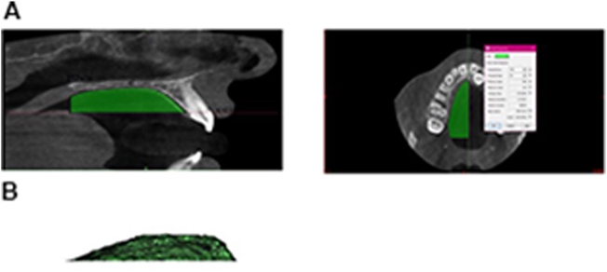
Figure 1. (A) Determination of the palatal volume the palate volume was measured in mid-sagittal view. The area of interest included the upper, lower, anterior and posterior vectors. (B) The 3D palate model was created in mimics software, version 21, using the dynamic region growing tool.
Results: The maxillary arch width on the impacted side was significantly less than the normal side (P<0.001). The mean depth of the palate was 14.86 ± 3.53 mm. There was a significant correlation between canine impaction and Palatal volume (R=0.728 and P-value<0.001), but no significant correlation between canine impaction and Maxillary arch width was shown (R=0.15 and p-value=0.326).
Conclusion: The impacted canine was significantly associated with a reduction in the width of the maxillary arch on the affected side and it made no difference if the impacted side was left or right. Also, impacted canine teeth were significantly associated with volume reduction on the affected side.
Biography
Soghra Yassaei has expertise in orthodontics and orthopedic treatment. According to her 25 years of clinical experience, she found that in patients with canine impaction who were undergoing orthodontic treatment, some impacted canines erupted spontaneously after palatal expansion without any orthodontic traction. She hypothesized that the volume of the palate of the affected patient is less. The purpose of this study was Evaluation of maxillary arch width and palatal volume and depth in patients with maxillary impacted canine by CBCT. She has an H-index of 10 and co-authored 60 publication(s) receiving 252 citation(s).

