Primary unilateral incomplete cleft lip repair by a modified rotational advancement technique
Sadam Elayah*, Yang Li and Bing Shi
Sichuan University, China
Abstract
Statement of the problem: Orofacial clefting has significant psychological and socioeconomic consequences for both the patient and the family, involving interruption of psychological adjustment and poor quality of life. Based on our many years of experience at our institute, we observed that the techniques designed for the Complete Cleft Lip (CCL) repair could not be suitable for Incomplete Cleft Lip (ICL) repair. This induced our institute to design a unique method for CCL repair as well as to design this present method for ICL repair, called Modified Rotational Advancement Technique (MRA).
Objective: This study aimed to describe a modified technique for primary unilateral incomplete cleft lip repair together with evaluation the postoperative outcomes.
Participants and setting: Photos of 64 consecutive patients with nonsyndromic primary unilateral incomplete cleft lip were reviewed. Among them, 32 patients had received Millard Rotational Advancement technique (RA), while the other 32 had Modified Rotational Advancement Technique (MRA) with preserving the nasal sill intact, within a university-affiliated tertiary hospital between 2013-2021.
Main measures: The lip measures were represented by lip height and width, vermillion height, midline-philtrum angle and angle of Cupid's bow peaks. The nasal measures involved columella length and angle, nostril height and width and ala width. Both descriptive and comparative analyses were calculated [Figure 1].
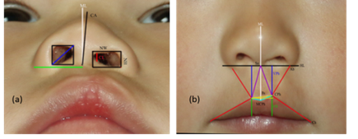
Figure 1. Measurements methodology; (a) nasal measurements (b) lip measurements.
Surgical technique: A surgical technique has been shown in (Figure 2).
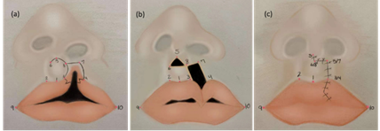
Figure 2. The modified rotational advancement design; (a) preoperative markings of the modified rotational advancement design, (b) intraoperative illustration of the incision, (c) postoperative scar shape.
Results: Symmetrical lip height, lip width, philtrum angle, Cupid's bow, as well columellar length and alar width were obtained following the MRA technique. No significant difference was found between the MRA and RA groups concerning the preoperative lip height, Cupid's bow angle, columellar length and angle. However, the postoperative lip height, width and columellar length were greater in MRA group than RA group (P=0.001, 0.004 and 0.002, respectively). On the other hand, the MRA group had significantly smaller columellar and Cupid's bow peaks angles than RA group (0.53 ± 0.36 vs. 1.21 ± 0.91 and 1.34 ± 1.84 vs. 3.14 ± 2.97, respectively) [Figure 3].
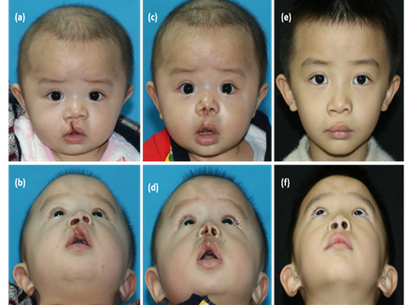
Figure 3. Children with right incomplete cleft lip who underwent to the Modified Rotational Advancement (MAR); (a) preoperative frontal view of (b) preoperative basal view of the same children (c) frontal view 7 days postoperative by MRA (d) basal view 7 days post-surgery (e) frontal view 4 years post-surgery (f) basal view 5 years post-surgery by MRA showing nostril sill intact with good overall appearance.
Conclusions: The MRA technique has obtained satisfactory lip and nasal outcomes in terms of lip height, lip width, philtrum angle, Cupid's bow, columellar length and alar width with keeping the nasal sill intact.
Biography
Sadam Elayah, Prof. Shi Bing’s master student, Cleft lip & Palate department-West China Hospital of Stomatology-Sichuan University, China.

