What makes the success of the management of immature necrotic permanent teeth?
Salima Bouaziz
University of Monastir, Tunisia
Abstract
The management of Immature Necrotic Permanent Teeth (INPT) presents a distinctive challenge for the endodontist due to compromised crown root ratio, thin root dentine walls and wide-open apex lacking an apical stop against which root filling materials can be condensed.
Various treatment modalities have been employed to create hard tissue barrier at the apex, which includes non-vital pulp therapy with calcium hydroxide, apexification with mineral trioxide aggregate, pulp revascularisation and regeneration [Figure 1].
The aims of this presentation are:
- To expose different factors influencing the success of the management of immature necrotic permanent teeth.
- To compare different therapies available in order to develop guidelines for the dentist for a better outcome.
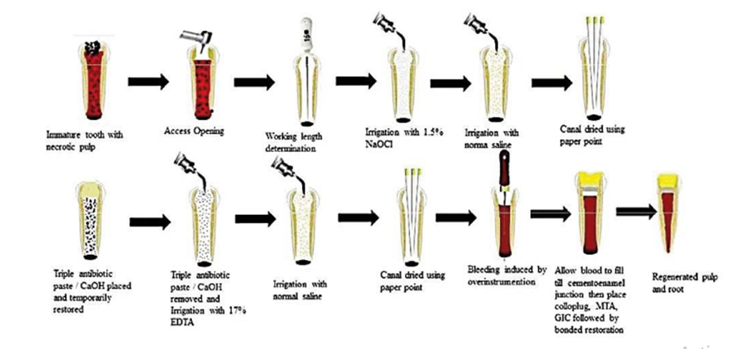
Figure 1. Protocol of regenerative endodontics.
Biography
Salima Bouaziz is a Dentist specialized in conservative odontology and Endodontics. After her training in university dental clinic of Monastir for 4 years as a resident in conservative odontology and endodontics service and obtaining her diploma, She have practiced specialized dentistry in her own office since December 2018. Her goal is to provide high-quality care for her patients given them a comfortable experience and exceptional result.

