Influenza and Pneumonia
Marian Hendy
Assiut University, Egypt
Abstract
Are symptoms different between Influenza and Pneumonia?
Pneumonia is a lung infection, so it has more respiratory symptoms while influenza is accompanied more by muscular aches and fatigue. Usually pneumonia takes longer to develop and can be a complication of influenza. The flu is caused by a viral infection, while pneumonia can be caused by either a bacterial, viral or fungal infection. Bacterial pneumonia can be an influenza complication. Immunosuppression is a risk factor for the secondary bacterial infection in influenza.
In flu season, every one of all ages is at risk of influenza, but the children are more vulnerable. Every region across the world is susceptible to the contagious respiratory illness, it can range from mild to severe in illness, so many patients with the flu recover within a few days, but some people can develop complications. One of the most significant complications is Pneumonia. One-third of pneumonia cases develop from a respiratory virus, with the flu the most common of those [Figure 1].
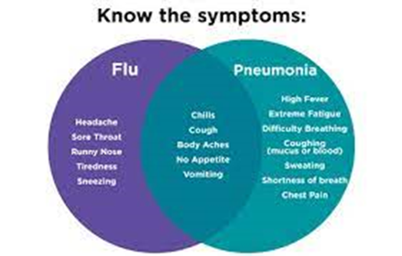
Figure 1. Know the symptoms.
Viral pneumonia in healthy people goes away in 1 to 2 weeks, but cough and fatigue may last for many weeks. Viral pneumonia can be serious and life-threatening in people with other medical illnesses. The best thing for a quick recovery from the influenza is rest and hydration, sometimes antiviral medication as oseltamivir can help to avoid complications as Pneumonia, especially in the immunocompromised patients, it can reduce the severity and duration of the symptoms as well.
Simple sanitization by wiping the surfaces with simple detergents, diluted bleach, or hydrogen peroxide, can help stop the spread of the influenza virus and control its seasonal breakdowns. Fortunately, there is a vaccine for both diseases, you can administer a pneumococcal vaccine (PCV15, PCV20 or PPSV23) and also influenza vaccination, this helps a lot to reduce the prevelance of both influenza and pneumonia in the pediatric population.
Biography
Marian Kamal Mankaryous Hendy is a Specialist in the Department of Paediatrics in Medcare Medical Centres. She obtained her MBBS and Master's Degree in Paediatrics and Neonatology from Assiut University in Egypt. She completed both her internship and residency at Assiut University Hospital. She started practicing as a Paediatrician at Assiut University Hospital and the Ministry of Health in Egypt. She then joined the Sohar Hospital in Oman where she worked as a Paediatric Specialist. Subsequently, she also worked as a Paediatric Specialist at Zulekha Hospital in Dubai for 5 years before joining Medcare.

