A novel mucin-selective protease StcE is a powerful tool for heavily O-glycosylated mucin proteins MS analysis
Ena Orzech¹*, Mark Pawlicki² and Daniel Taglicht¹
¹Merck, Israel
²MilliporeSigma, USA
Abstract
Mucins, major components of the extracellular mucus are a family of high molecular weight, heavily glycosylated proteins. In most animals these proteins are produced by epithelial tissues and can serve as biomarkers for abnormal conditions such as ovarian and lung cancers. Mucins consist of a polypeptide backbone of hundreds to thousands of amino acids; the glycosylation of the mucins can contribute to over 50% of the total protein mass. Mucin domains are notable for their high frequency of Ser (S) and Thr (T) residues which are O-glycosylated with α-N-acetylgalactosamine (α-GalNAc). This leads to dynamic and very heterogenous glycoprotein populations which cannot be predicted from genomic information only. Investigating biological functions of mucins at the molecular level is a challenge, as only few tools are available to probe mucin domains.
The secreted protease of C1 esterase inhibitor (StcE) from Escherichia coli (O157:H7) is a mucin specific bacterial metalloprotease that recognizes a specific consensus sequence and cleaves the mucin polypeptide proximal to an O-glycosylated serine or threonine. The Mucin-selective proteolysis by Stc was discovered as a novel and a powerful tool for the study of mucin domain structure and function, by Malaker [Figure 1].
At Merck we have further developed these tools to be available as research reagents under license from the lab of Caroline Bertozzi lab at Stanford University.
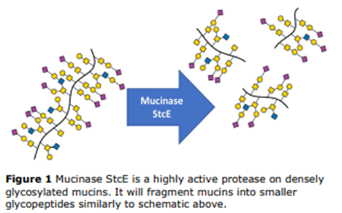
Figure 1. Mucinase StcE is a highly active protease on densely glycosylated mucins. It will fragment mucins into smaller glycopeptides similarly to schematic above.
Biography
Ena Orzech is working at Merck Life Sciences R&D and has 20 years’ experience in new product development, specializing in protein expression and purification. During her work she has development variety of recombinant proteins and had designed different kits. During the present work she gained extensive experience in protein expression in E.coli bacteria expression system and in Pichia pastoris. Expression in Pichia pastoris system includes cloning into Pichia expression vectors, transformation, screening for stable clones, expression and purification.

