Molecular basis for substrate recognition and septum cleavage by AtlA, the major N-acetylglucosaminidase of Enterococcus faecalis
Zamboni V, Barelier S, Dixon R, Galley NF, Ghanem A, Nguyen QP, Cahuzac H, Salamaga B, Davis PJ, Bourne Y, Mesnage S and Vincent F*
Aix-Marseille University, France
Abstract
The cleavage of septal peptidoglycan at the end of cell division facilitates the separation of the two daughter cells. The hydrolases involved in this process (called autolysins) areb potentially lethal enzymes that can cause cell death; their activity, therefore, must be tightly controlled during cell growth. In Enterococcus faecalis, the N-acetylglucosaminidase AtlA plays a predominant role in cell separation. atlA mutants form long cell chains and are significantly less virulent in the zebrafish model of infection. The attenuated virulence of atlA mutants is underpinned by a limited dissemination of bacterial chains in the host organism and a more efficient uptake by phagocytes that clear the infection. AtlA has structural homologs in other important pathogens, such as Listeria monocytogenes and Salmonella typhimurium and therefore represents an attractive model to design new inhibitors of bacterial pathogenesis. Here, we provide a 1.45 Å crystal structure of the E. faecalis AtlA catalytic domain that reveals a closed conformation of a conserved β-hairpin and a complex network of hydrogen bonds that bring two catalytic residues to the ideal distance for an inverting mechanism. Based on the model of the AtlA–substrate complex, we identify key residues critical for substrate recognition and septum cleavage during bacterial growth [Figure 1].
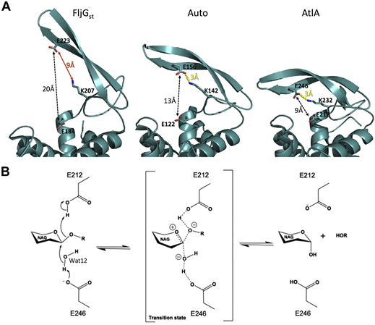
Figure 1. The AtlA catalytic mechanism involves the motion of the β-hairpin to close the active site and place the catalytic residues at the right distance to hydrolyze the glycosidic bond using an inverting mechanism.
Biography
Florence Vincent obtained a PhD in 2001 in Structural Biology from the University of Aix-Marseille (Mentor: Dr. Christian Cambillau) and post-doctoral training in 2001-2004 at York Structural Biology Laboratory, Dept. Chemistry (Mentor: Dr. Gideon Davies), UK. She is currently a research scientist in the team “Structural Glycobiology and Neurobiology” at the Architecture and Function of Biological Macromolecules Laboratory, Aix-Marseille University, Marseille, France. Her current interests are the structure and function of enzymes involved in bacterial cell wall lysis and biofilm development by pathogenic bacteria.

