Decentral Hydrogen
Paul Grunow
Trinity Solarbeteiligungen GmbH, Germany
Abstract
Decentral hydrogen is introduced as fast transition path to short and long-term power storage. It circumvents slow infrastructure installments and enables on-site storage and heat coupling in addition to direct use of local electric power. The power-to-gas approach is extended to small combined heat and power devices in buildings that alternately operate fuel cells and electrolysis. While their heat is used to replace existing fossil heaters on-site, the power is either fed into the grid or consumed via heat-coupled electrolysis to balance the grid power at the nearest grid node. In detail, the power demand of Germany is simulated as a snapshot for 2030 with 100% renewable sourcing. The standard load profile is supplemented with additional loads from 100% electric heat pumps, 100% electric cars, and a fully electrified industry. The renewable power is then scaled up to match this demand with historic hourly yield data from 2018/2019. An optimal mix of photovoltaics, wind, biomass and hydropower is calculated in respect to estimated costs in 2030. In most master plans, hydrogen is understood to be a substitute for fossil fuels. This talk focuses on hydrogen as a storage technology in an all-electric system. The target is to model the most cost-effective end-to-end use of local renewable energies, including excess hydrogen for the industry. The on-site heat coupling is the principal argument for decentralization here. Essentially, it flattens the future peak from exclusive usage of electric heat pumps during cold periods. Batteries are tried out as supplementary components for short-term storage, due to their higher round trip efficiencies. Switching the gas net to hydrogen is considered as an alternative to overcome the slow infrastructure expansions. Further decentral measures are examined in respect to system costs [Figure 1].
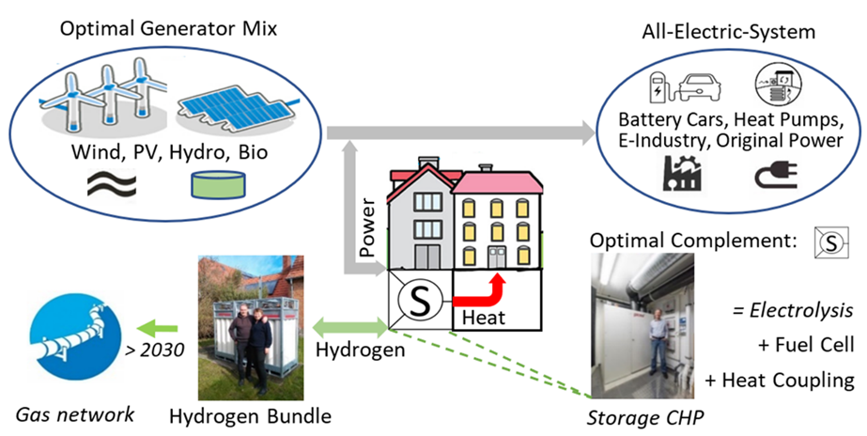
Figure 1. Decentral 100% renewable energy system with Storage CHP.
Biography
Paul Grunow has completed his PhD at the age of 30 years from Technical University Berlin and Helmholtz-Zentrum Berlin and postdoctoral studies from the COPPE/UFRJ in Rio de Janeiro, Brazil. He is the general manager of Trinity Solarbeteiligungen GmbH, an investment company in renewable energies. Before, he co-founded three companies in the area of photovoltaics based in Berlin, i.e. Solon, Q-Cells, PI Photovoltaik-Institut Berlin. He has published more than 12 papers in reputed journals.

