Seaweeds waste biomass for a clean and sustainable environment
Nour Shafik El-Gendy
MSA University, Egypt
Abstract
Millions tons of seaweeds waste biomass is annually produced all over the world. Such waste biomass is not economically reused, damaging our shorelines, affecting touristic activities and negatively impacting coral reefs, aquatic life and biodiversity. That consequently, negatively impacts the achievements of the sustainable development goals. Valorization of such wastes is a feasible process to reach a sustainable and clean environment. It can be successfully applied for; production of valuable products; e.g. nano-materials, biocides, green- catalyst for biodiesel production and photo-catalytic degradation of different pollutants, wastewater treatment, production of different kinds of biofuels as complementary and/or alternative to petro-fuels. Thus, valorization of such aquatic wastes with the concept of reaching zero-waste and achieving the circular economy is a promising criteria for accomplishing the three pillars of sustainability; economy, society and environment [Figure 1].
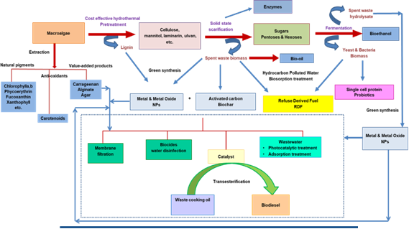
Figure 1. Graphical abstract.
Biography
Nour Shafik El-Gendy is a Professor in the field of Environmental Sciences, Sustainable development, Clean Energy and Nano-Biotechnology. She published 10 chapters, 9 books and 124 research papers and supervised 29 MSc and PhD theses. She is also an editor and reviewer in 88 and 184 international journals, respectively. She participated also as PI, Co-PI or research member in research projects concerning with; biovalorization of wastes, solid waste management, bioethanol from lignocellulosic wastes; biofuels from algae, application of nanobiotechnology in upgrading of petroleum and bioremediation of polluted environment. She is in international collaboration with many international universities and research institutes. She established 4 ongoing research schools; Petroleum and Environmental Biotechnology, Environmental Nanobiotechnology, Biofuels and Valorization of Solid Waste Biomass. She is a member in many national and international associations and organizations concerned with petroleum industry, environmental health and sciences, sustainable development, water desalination, wastewater treatment, biofuel standards, nanotechnology and environmental biotechnology.

