Electrocoagulation flotation-based zero chemical operation of low cost and energy efficient municipal wastewater pre-treatment
Nazia Hassan*, Dries Parmentier and Stijn Wim Henk Van Hulle
Ghent University, Belgium
Abstract
Statement of the problem: Municipal Waste Water (MWW) treatment technology application into real world depends on efficient operation at lower energy and chemical costs when reducing the environmental pollution. In the last two decades, Electro-Coagulation-Flotation (ECF) was investigated with either synthetic MWW or with adjusted pH and conductivity, utilizing different Current Densities (CDs) in batch mode. This study aimed to optimize ECF for real waste water treatment in a continuous mode.
Methodology & theoretical orientation: Iron (Fe) sacrificial tubular metal anode used to treat freshly collected MWW at 10 L/h flow rate. Different cathode materials (Copper(Cu) and Stainless Steel(SS)), Two or Three times Recirculation (2R and 3R) of ECF treated effluents and Alternating Plus Current (APC) supply versus Direct Current (DC) supply were set as different parameters for optimization at various CDs (i.e., 12,24,36,40,80,120 and 160 A/m²). Optimized performances were evaluated based on removal of total Chemical Oxygen Demand (tCOD), Total Phosphate (TP), Total Nitrogen (TN) and three types of total Operational Expenses (OPEX) (sum of energy and electrode consumption). Heavy metals analysis was done also.
Findings: Operation of Fe ECF unit with 2R at 12 A/m² resulted in optimized treatment performance, i.e. 78 ± 11% tCOD, 85 ± 0.5% TP and 32 ± 22% TN removal at the lowest total OPEX (0.032 ± 0.001 Euro(€)/m³) [Figure 1]. The obtained lowest OPEX were 0.13 ± 0.07 €/Kg tCOD removal and 24.60 ± 3.85 €/Kg TP removal. Sludge production was also found lowest. Fe ECF was found beneficial to remove heavy metals (93 ± 9% Zn, 70 ± 15% Pb and Cu 49 ± 10%).
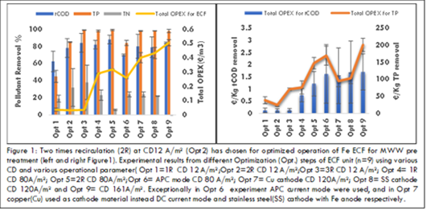
Figure 1. Two times recirculation (2R) at CD 12 A/m² (Opt 2) has diosen for optimized operation of Fe ECF for MWW pretreatment. Experimental results from different Optimization (Opt) steps of ECF unit (n=9) using various CD and various operational parameter (Opt 1=1R CD 12 A/m², Opt 2=2R CD 12 A/m², Opt 3=3R CD 12 A/m²; Opt 4=IR CD 80 A/m², Opt 5=2R CD 80 A/m², Opt 6=APC mode CD 80 A/m², Opt 7=Cu cathode CD 120 A/m², Opt 8=SS cathode CD 120 A/m² and Opt 9 CD 161 A/m². Exceptionally in Opt 6 experiment APC current mode were used, and in Opt 7 Copper (Cu) used as cathode material instead DC current mode and Stainless Steel (SS) cathode with Fe anode respectively.
Conclusion: Effluent of 2R Fe ECF at CD 12 A/m² (Opt2) contained higher biodegradable matter and TN, suitable for subsequent simple biological treatment. In summary, ECF technology becomes a feasible technology by facilitating zero chemical use and energy efficient low cost MWW pre-treatment unit around the world. As well as potentially reduce footprint of conventional MWW treatment plant and control environmental pollution to attain environmental sustainability.
Biography
Nazia Hassan has her expertise in wastewater treatment and water quality management to protect environmental pollution as well as public health. Her PhD work on zero chemical Electro-Coagulation-Flotation (ECF) system used to treat Municipal Waste Water (MWW) of Kortrijk, Belgium and Khulna, Bangladesh, funded by Prime Minister Fellowship Fund of Bangladesh Government. She demonstrated efficient removal of tCOD, TP, turbidity, heavy metals, and pathogens. Optimized Fe ECF unit excelled for low-cost and energy-efficient operation with environmental suitability. As a current PhD student of LIWET group under Department of Green Chemistry and Technology under Ghent University, Belgium and a faculty member of Environmental Science Discipline, Khulna University, Bangladesh (since 2008), she has experiences in research, teaching, guiding thesis students and administration. ECF technology for MWW pretreatment facility creates an enormous opportunities in both developing and developed countries for sustainable developments. As well as bridging knowledge and technology transfer from developed to developing countries.

