Selective detection of diethanolamine utilizing LMR/LSPR based optical fiber sensor
Kavita¹*, Jyoti¹, Shruti Gupta¹, Kiran Kumar Tejavath¹ and Verma RK²
¹Central University of Rajasthan, India
²University of Allahabad, India
Abstract
In the present study, we have designed a Lossy Mode Resonance (LMR)/LSPR based optical fiber sensor for the detection of diethanolamine (DEA). In order to achieve the required outcomes, two optical fiber probes were fabricated (1) TiO₂ bulk layer coated optical fiber probe and, (2) TiO₂/AuNPs bilayer coated optical fiber probe. Characterization such as FESEM, HRTEM and UV-visible spectra are used for the confirmation of the prepared optical fiber probes. Sensitivity of TiO₂ bulk layer/AuNPs bilayer coated optical fiber probe is numerically observed 16079.63 nm/RIU or 0.074 nm/mM which is approximately double the sensitivity of the TiO₂ bulk layer coated optical fiber probe. Performance of our sensor is assessed with the calculation of some other parameters such as Limit of Detection, Figure of Merit, repeatability and response time. To make this sensor highly sensitive to DEA a selectivity experiment is also performed. From the best of our knowledge, this is the first attempt for detection of DEA with LMR based optical fiber sensor. Authors believe that this research will be very valuable for the approaching researchers for the development in this field. Further research should concentrate on the use of nano-structures for enhanced optimization and capability [Figure 1].
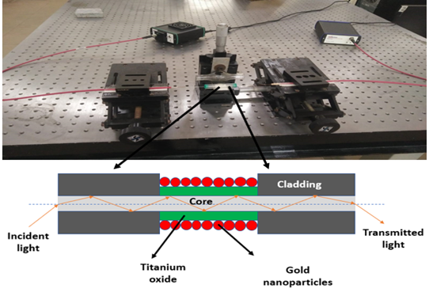
Figure 1. Pictorial representation of proposed optical fiber probe.
Biography
Kavita has expertise and passion in her field of research. She is very focused and sincere about her work. She has one and half years’ experience of working in a project. She has experience of working with some software like Origin, MATLAB, COMSOL and LaTex etc. She is working theoretically and experimentally both, on the fabrication of sensor and biosensor. She has successfully fabricated a selective ethanol/methanol detection sensor, used the enzymes and co-enzyme technique for urea detection in milk which is another publication.

