Assessment of risk factors of cholera among female’s employees in Sanaa University, Yemen
Fares A. Mahdi*, Safa A. Kutib, Soad A. Sharkawy and Fayza M. Mohammed
Assiut University, Egypt
Abstract
Introduction: Cholera is a contagious infection that can be fatal; in spite of this, it can be easily prevented by sticking to proper hygienic measures as well as administering cholera vaccine. The World Health Organization estimates that up to 4 million global cholera cases occur each year, resulting in 21,000-143,000 deaths [Figure 1]. Aim of this study was to determine the prevalence and risk factors associated with cholera transmission in Sana'a city, Yemen.
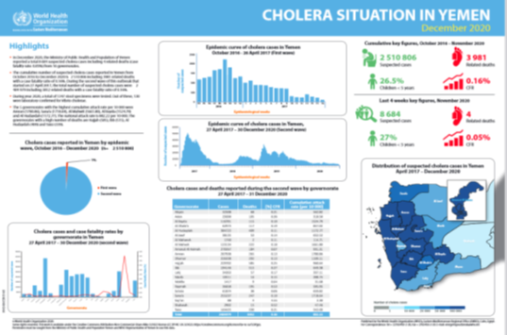
Figure 1. WHO 2020.
Methodology: We conducted an unmatched case–control study. Cases were identified from health unit records of Sana'a University; we interviewed 230 participants on socio-economic, household hygiene, food and water exposures practices using a semi-structured questionnaire. Data was analyzed using SPSS 22 versions, P<0.05 was considered to be statistically significant.
Results: The results The 230 participants included 45 (19.5%) cholera cases and 185 (80.5%) controls. Ages ranged from 15 years to 65 years; with mean of (20.0 ± 47.0) years. The cholera attack rate was 0.16 % with no fatality according WHO Report 2017. Most participants 206 (89.5%) had heard of cholera. Poor hygienic practices 199 (85.5.2%) and contaminated water sources 159 (69.1%) were the main reported transmission routes of cholera. Good hygienic practices 211 (91.7%) were the main preventive methods of cholera in both cases 45 (84.6%) and controls [185 (89.0%)]. Risk factors of cholera in the study population analysis showed most participants 186 (80.8%) practiced good food preservation methods. Moreover, many 108 (46.9%) ate outside their homes such as in restaurants. Those with cholera were 11.2 times more likely to practice poor food preservation methods than those without the disease p<0.0001).
Conclusion: The level of knowledge of the female's employees is poor and requires educational program to be improved. Improvement in hygiene and sanitation conditions coupled with water infrastructural development is crucial to combating the cholera epidemic.
Keywords: Cholera, Knowledge, Attitude, Practice, Epidemic.
Biography
Fares Mahdi has completed PhD degree in Community Health Nursing at the age of 35 years from Assiut University –Egypt and he is an Assistant professor in community health nursing in IBN Al-Nafis University–Faculty of Nursing. He is a senior case worker and facilitator in Medical access program in Saint Andrew's Refugee Services Egypt. He is also First Aid Trainer.

