Core health: Operating center of telemedicine for chronic diseases and clinical networks of Apulia Region
Giovanni Gorgoni, Pasquale Notarangelo and Vito Petrarolo
Regional Strategic Agency for Health and Social Affairs (AReSS), Italy
Abstract
Statement of the problem: The transformation of remote healthcare pathways (telemedicine) in Apulia starts a long time ago with the por Puglia 2014-2020 projects: hlcm and talisman (winner of the digital innovation award in healthcare 2021) from which core health directly derives, set up at AReSS.
Methodology & theoretical orientation: Core health offers: hl7-fhir interoperable web-cloud platform; televisit, teleconsultation, telemonitoring, telecooperation and teleconference; device tracking system; patient synoptic; central alarms; mobile app for citizens (android/ios); integration with the regional health information system, the electronic health record and others. The app promotes the patient's involvement in the care process: keeping in touch with your specialist doctor and caregiver (video calls/chat); consult the agenda of the televised programs with your care team; view your care plan; enter the vital parameters that are communicated to the doctor in real time; manage their clinical diary and possibly share it with the care team; facilitate the measurement of compliance with the treatment path. From January 2022 the transformation of the Apulian oncological network into a digital key was started and therefore the training of the operators of the oncological guidance centers and the breast units and the enrollment of about 23,000 cancer patients.
Findings: AReSS has launched a virtuous path of training, change management and digital literacy for all users of the system (medical and administrative teams) and for patients to promote continuous training and the consolidation of digital skills. Core health overturns the traditional patient care pathways, bringing, for the first time, digital innovation directly into their hands (app mobile) allowing them to have their own medical history, their treatment plan and to maintain a constant and regulated dialogue with your doctor, the medical team and the care giver, as well as being able to take the most suitable measurements for the management of your pathology [Figure 1].
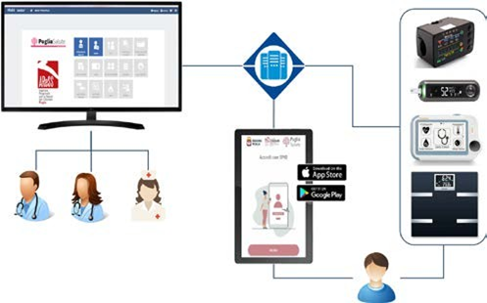
Figure 1. CORēHealth IT Architecture logical model.
Biography
Giovanni Gorgoni is an economist with a degree in Business Economics from the Bocconi University of Milan, a master's degree in Healthcare Management from the Bocconi School of Management in Milan and a master's degree in Facility Management from the Campus Bio-Medico University of Rome. From December 2016 until today he is General Manager of AReSS (Regional Agency for Health and Social Care of Apulia), the Apulian government agency for the strategic planning of social and health policies. He is currently a member of the national control room for chronic diseases and a member of the executive committee of EuroHealthNet in Brussels.

