Deep learning based multimodal human activity recognition in ehealth applications
Fakhri Karray
University of Waterloo, Canada
Abstract
eHealth systems, a topic of recently growing interest, have become increasingly more widespread due to the development of contemporary technologies to provide healthcare services to everyone. Human Activity Recognition (HAR) has emerged as one of the most vibrant research fields due to their essential deployments in a variety of domains, such as industry 5.0 applications including smart homes, ambient assisted living, personal care and several Internet of Things (IoT) applications. Deep learning based approaches have demonstrated remarkable performance to recognize human activities thanks to their automatic feature learning capabilities. Although several intelligent frameworks have been evolved over the last decades by several research communities, only a few of the architectures are compatible to handle different nature of data. We proposed a feature fusion technique for multimodal human activity recognition using CNNs with attention module to process the visual data and Convolutional Long Short Term Memory (ConvLSTM) for dealing with the time-sensitive multi-source sensor information. Several extensive statistical tests were run to assess the efficiency and robustness of the proposed fusion approach using a publicly available HAR dataset called UP-Fall detection dataset. The experimental findings revealed that the proposed fusion architecture obtained superior performance to classify human activities from multimodal data. Moreover, we developed an IoT platform to evaluate the proposed fusion architecture in real-world smart healthcare applications [Figure 1].
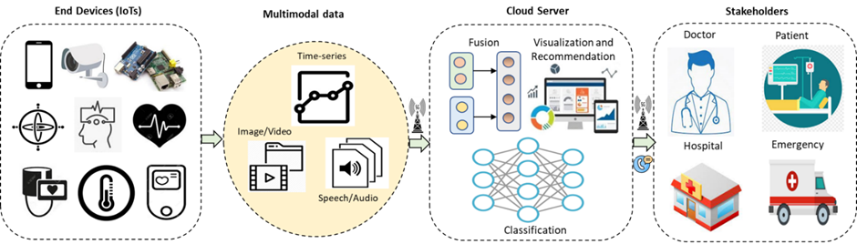
Figure 1. System architecture of the multimodal human activity recognition for eHealth applications.
Conclusion: The results of the proposed architecture show that it is relevant to perform activity recognition with a high degree of confidence and has the potential to influence many intelligent applications on the eHealth platform.
Biography
Fakhri Karray is Professor of Machine Learning at the MBZ University of AI and is the University Research Chair Professor in Electrical and Computer Engineering and the founding co-director of the Institute of Artificial Intelligence at the University of Waterloo. He holds the Loblaw’s Research Chair in Artificial Intelligence. His research work spans the areas of intelligent systems and operational artificial intelligence as applied to smart devices and man machine interaction systems through speech, gesture and natural language. He has authored extensively in these areas and has disseminated his work in journals, conference proceedings and textbooks. He is the co-author of two dozen US patents, has chaired/co-chaired several international conferences in his area of expertise and has served as keynote/plenary speaker on numerous occasions. He has served as the associate editor/guest editor for a variety of leading journals in the field, including the IEEE Transactions on Cybernetics, the IEEE Transactions on Neural Networks and Learning Systems, the IEEE Transactions on Mechatronics, the IEEE Computational Intelligence Magazine. He has served as the University of Waterloo’s Academic Advisor for Amazon’s Alexa Fund Fellowship Program and is a Fellow of the Canadian Academy of Engineering, a Fellow of the Engineering Institute of Canada and a Fellow of the IEEE.

